



Implemented by

|  |  |
| --- | --- |
| *20210479* | *Youssef Emad* |
| *20210009* | *Ahmed Osama* |
| *20210318* | *Mazen Mahmoud* |
| *20210554* | *Ahmed Magdy* |
| *20210230* | *Abdelrhman Mohamed* |

Supervised by

*Dr. Basher Abdelfattah*

Graduation Project

Academic Year 2024-2025

Final Year Document

**Abstract**

The growth of e-commerce changes customer behavior and increases the demand for efficient last-mile delivery service. The rapid increase in daily orders has made the Traditional tools inefficient to manage delivery processes, and raise some issues like Costs become higher, increase in delivery delays and increase customer dissatisfaction. Last mile delivery is a very important and sensitive process as it represents 53% of total shipping cost.

Delma is an intelligent Delivery Management System. It was designed to automate, streamline and optimize last mile delivery processes for businesses and help them to manage their couriers efficiently.

Our motivation is to enhance business efficiency, reduce costs, and improve customer satisfaction. Delma uses advanced tools, including automated order management, smart dispatching algorithms, optimized route planning, real-time tracking, and a courier mobile app. These features reduce human intervention, delivery delays, and operational costs while enhancing resource utilization and transparency. With Delma, businesses can achieve significant cost savings, improved delivery performance, and better customer experience.

# Contents

Contents 3

List of Figures 5

Table of Abbreviations 6

**Chapter 1: Introduction** 7

**1.1 Motivation** 8

**1.2 Problem Definition** 9

**Current State Analysis:** 9

**Specific Problems Addressed:** 9

**1.3 Project Objective (Suggested Solution)** 10

**1.4 Gantt Chart of Project Time Plan** 12

**1.5 Project Development Methodology** 13

**1.6 The Used Tools in the Project** 14

1.6.1 Software Tools (SW) 15

1.6.2 Hardware (HW): 16

**1.7 Report Organization** 17

**Chapter 2: Related Work** 19

2.1 The Existing Solutions: 19

**1. Roboost *(AI-Powered Delivery Automation – Egypt, MENA)*** 19

**2. Circuit for Teams *(Route Optimization – Global)*** 20

**3. OptimoRoute *(Advanced Route & Schedule Planning – Global)*** 20

**4. Bosta *(Courier Management as a Service – Egypt)*** 21

**5. Talabat / Elmenus / Noon *(Food & Retail Aggregators – Regional Giants)*** 22

***The main differences between Delma and related work*** 23

2.2 Comparing Our Presented Approach to Previous Work: 23

**Chapter 3: System Analysis** 24

**3.1 Project Specification** 24

**3.1.1 Functional Requirements** 24

**Owner Role Functional Requirements** 24

**Operator Role Functional Requirements** 25

**Admin Functional Requirements** 26

**Courier Role Functional Requirements** 26

**3.1.2 Non-Functional Requirements (Based on Implementation)** 27

**Usability** 27

**Performance** 27

**Security** 28

**Availability** 28

**Maintainability** 28

**3.1 Use Case Diagram** 29

**Chapter 4: System Design** 30

**4.1 System Architecture** 31

**4.2 System Component Diagram** 32

**4.3 System Class Diagram** 33

**4.4 Sequence Diagrams** 34

4.3.1 Admin interactions: 34

4.3.2 Courier interactions: 36

4.3.3 Owner interactions: 38

4.3.4 Operator interactions: 39

**4.6 System GUI Design** 43

4.6.1 Mobile Application: 43

4.6.2 Website: 45

**Chapter 5: Implementation and Testing** 56

5.1 implementation 56

5.1.1 Web implementation 56

**System Architecture** 56

**Tools and Technologies Used** 57

**Modules and Components** 58

**Challenges and Solutions** 60

**Assignment Algorithms and Optimization** 61

**Overview** 61

**Implemented Algorithms** 61

**Algorithm Selection Logic** 62

**Comparison Metrics** 63

**Performance Evaluation Framework** 63

**Algorithm Comparison Process** 63

**Operational Considerations** 64

5.1.2 Application Implementation 65

5.2 Testing: 66

5.2.1 Application tests 66

5.2.1.1 Login 66

5.2.1.2 order details 67

5.2.1.3 Optimized Route 68

Chapter 6:Future work and Conclusion 70

6.1 Future work: 70

6.2 Conclusion: 71

References 73

# List of Figures

Figure 1. Last Mile Delivery Market stat 8

Figure 2. Delima Gantt Chart 12

Figure 3. use case diagram 29

Figure 4. System Architecture 31

Figure 5. Component Diagram 32

Figure 6. class diagram 33

Figure 7. activate/deactivate store 34

Figure 8. view stores 35

Figure 9. change order status 36

Figure 10. mark availability 37

Figure 11. view order details 37

Figure 12. add branches 38

Figure 13. remove branches 38

Figure 14. edit branches 39

Figure 15. add couriers 39

Figure 16. delete couriers 40

Figure 17. update order 41

Figure 18. ERD diagram 42

Figure 19. Orders list 43

Figure 20. complete Order 43

Figure 21. Login 43

Figure 22. map View 43

Figure 23. Cancel Order 44

Figure 24. Chained Orders 44

Figure 25. change password 44

Figure 26. home page 45

Figure 27. more of home page 46

Figure 28. payment plans 47

Figure 29. registration 48

Figure 30. view orders on map 49

Figure 31. list of orders 49

Figure 32. Assignment center 50

Figure 33. product managment 51

Figure 34. analytics 52

Figure 35 zone managment page 53

Figure 36. branches managment 54

Figure 37. team managment page 55

Figure 38. flutter project tree 1 65

Figure 39. flutter project tree 2 65

Figure 40. view order test 68

Figure 41. view optimized route test 69

# Table of Abbreviations

|  |  |  |  |
| --- | --- | --- | --- |
| CDN | Content delivery network | JWT | json Web Tokens |
| CAGR | Compound Annual Growth Rate | RBAC | role-based access control |
| API | Application Programming interface | CRUD | Create, Read, Update and Delete |
| POD | Proof of delivery | ML | machine learning |
| ETA | Estimated time of arrival | S3 | Amazon Simple Storage Service |
| MTTR | mean time to recovery | ESLint | ECMAScript Lint |
| SPA | Single Page application |  |  |
| ORM | object-relational mapping |  |  |

# **Chapter 1: Introduction**

The modern e-commerce and food delivery landscape is characterized by rapid growth, increasing customer expectations, and complex logistical challenges. Businesses, from small local stores to large multi-branch enterprises, struggle with inefficient manual processes, lack of real-time visibility, and fragmented delivery operations. These issues lead to delayed deliveries, dissatisfied customers, high operational costs, and limited scalability. The absence of a unified, intelligent system for managing multi-store operations, courier assignments, and real-time tracking significantly hinders growth and profitability.

DELIMA (Delivery Management System) is proposed as a comprehensive, intelligent solution designed to revolutionize delivery logistics. It addresses critical pain points by offering multi-store delivery operations management, real-time courier tracking and assignment, geographic zone-based optimization, and robust analytics. DELIMA aims to streamline the entire delivery workflow, from order placement to final delivery, ensuring efficiency, transparency, and scalability. Its key benefits include reduced delivery times, enhanced customer satisfaction, optimized resource utilization, and significant cost savings. DELIMA targets a broad market, including e-commerce businesses, food delivery services, and any enterprise requiring sophisticated, scalable last-mile delivery capabilities. This platform will empower businesses to overcome current logistical hurdles, foster growth, and deliver exceptional service.

## 

## **1.1 Motivation**

In today’s fast-paced world, as the number of internet users and online consumers increases, the increasing volume of daily orders has made delivery management more complex and inefficient. Businesses struggle with delays, rising operational costs, all of which negatively impact business performance and customer experience.

Figure 1. Last Mile Delivery Market stat

The global last mile delivery market size was valued at USD 161.20 billion in 2024 and is expected to grow from USD 176.99 billion in 2025 to reach USD 373.92 billion by 2033, growing at a CAGR of 9.8% during the forecast period (2025-2033).

Increasing the complexity of the last mile delivery process raises some issues and challenges. So, Existing powerful and intelligent solution that can overcome the last mile delivery issues and gain customer experience will be a great thing.

Delma was designed to overcome the last mile delivery challenges. It is a smart and powerful delivery management solution that helps businesses of all sizes across different industries automate and streamline their delivery operations. With features such as automated order management and dispatching, optimized route planning using algorithms, and real-time tracking, Delma reduces delays, lowers operational costs, and enhances overall efficiency.

Whether you are a retail store, restaurant or e-commerce business, Delma will empower you to take full control of your delivery operations.

## **1.2 Problem Definition**

The current state of delivery management, particularly for businesses operating multiple stores or branches, is fraught with inefficiencies and significant pain points across all stakeholders. Traditional and often manual approaches are no longer sufficient to meet the demands of a fast-paced, digitally-driven market, leading to substantial operational and financial drawbacks.

### **Current State Analysis:**

* **Challenges in Traditional Delivery Management:** Many businesses still rely on rudimentary methods like phone calls, spreadsheets, and basic messaging apps to coordinate deliveries. This fragmented approach lacks centralization, leading to miscommunications, duplicated efforts, and a high potential for human error. Without integrated systems, it's nearly impossible to gain a holistic view of ongoing operations.
* **Pain Points for Store Owners, Couriers, and Customers:**
  + **Store Owners/Managers:** Struggle with assigning deliveries efficiently, especially across multiple locations. They lack real-time visibility into courier locations and delivery statuses, making it difficult to manage exceptions or provide accurate customer updates. Manual dispatching is time-consuming and prone to errors.
  + **Couriers:** Often face inefficient routing, leading to longer travel times and increased fuel costs. They may receive assignments haphazardly, without consideration for their current location or capacity. Lack of clear communication channels with stores and customers can lead to frustration and delays.
  + **Customers:** Experience frustration due to inaccurate delivery time estimates, lack of real-time tracking, and delayed deliveries. This directly impacts customer satisfaction and loyalty, leading to negative reviews and potential churn.
* **Inefficiencies in Manual Delivery Processes:** Manual processes are inherently slow and resource-intensive. Assigning deliveries manually, communicating updates via phone, and tracking progress without automated tools consume valuable time and labor. This limits the number of deliveries a business can handle, impeding scalability and profitability.
* **Lack of Real-time Visibility and Coordination:** Without a centralized system, businesses operate in the dark. There's no real-time overview of all active deliveries, courier availability, or potential bottlenecks. This absence of immediate data prevents proactive decision-making and efficient problem resolution, leading to reactive crisis management.

### **Specific Problems Addressed:**

* **Multi-location Store Management Complexity:** Businesses with multiple branches face immense challenges in coordinating deliveries across different locations. Each store might operate independently, leading to inconsistent service quality, duplicated efforts, and a lack of consolidated performance data. Managing a unified delivery fleet for disparate locations becomes a logistical nightmare.
* **Inefficient Courier Assignment and Routing:** Manual or simplistic assignment methods often result in couriers being dispatched inefficiently, leading to suboptimal routes, increased travel distances, and higher operational costs. This also reduces the number of deliveries a single courier can complete, impacting overall capacity and profitability.
* **Poor Delivery Time Estimation and Tracking:** Inaccurate estimated times of arrival (ETAs) are a major source of customer dissatisfaction. Without real-time tracking capabilities, customers are left guessing about their order's status, leading to increased calls to customer service and a diminished brand experience.
* **Lack of Centralized Order Management:** Orders often originate from various channels (e-commerce platforms, phone calls, in-store). Without a centralized system to aggregate and manage these orders, businesses struggle with a unified dispatching process, leading to missed orders, delayed processing, and operational chaos.
* **Difficulty in Scaling Delivery Operations:** As businesses grow, their delivery volume increases exponentially. Manual systems quickly become overwhelmed, making it impossible to scale operations efficiently without a proportional increase in administrative overhead and costs. This bottleneck stifles growth potential.
* **Inadequate Performance Analytics and Reporting:** Most traditional systems offer little to no actionable data on delivery performance. Businesses lack insights into key metrics such as average delivery time, courier efficiency, customer satisfaction trends, or peak delivery hours. This absence of data prevents informed decision-making and continuous improvement.

These pervasive problems highlight a critical need for a sophisticated, integrated delivery management system that can bring order, efficiency, and intelligence to the complex world of last-mile logistics.

## **1.3 Project Objective (Suggested Solution)**

The primary objective of the DELIMA project is to develop a comprehensive, state-of-the-art delivery management platform designed to revolutionize logistics operations for e-commerce and food delivery businesses. This platform aims to transcend the limitations of traditional systems by integrating advanced functionalities that ensure efficiency, transparency, and scalability. A core objective is the implementation of real-time tracking and optimization capabilities, enabling precise monitoring of couriers and dynamic adjustment of routes to account for unforeseen variables such as traffic or weather conditions. Furthermore, the project seeks to create a scalable multi-store architecture, allowing businesses to manage numerous branches and diverse product inventories from a single, unified interface. This architecture will support seamless expansion and adaptation to growing business needs without compromising performance. Finally, a key objective is to provide advanced analytics and reporting features, transforming raw operational data into actionable insights that can drive strategic decision-making and continuous process improvement.

The solution approach adopted by the DELIMA project centers on the creation of an integrated platform that consolidates all facets of delivery operations. This unified system will serve as a central hub for order management, courier dispatch, and real-time tracking, eliminating the fragmentation often found in current systems. Real-time location tracking, powered by GPS and mobile technology, will be a cornerstone of the platform, providing continuous updates on courier positions and delivery progress. This real-time visibility will be complemented by sophisticated communication channels, allowing for instant updates to customers and seamless interaction between couriers, stores, and administrators. Intelligent courier assignment algorithms will be developed to optimize dispatching based on factors such as courier availability, proximity to the pickup location, delivery zone, and current traffic conditions, ensuring the most efficient allocation of resources. Geographic zone optimization will allow businesses to define and manage specific delivery territories, apply variable fees, and enforce restrictions, thereby streamlining pricing and operational boundaries. All these functionalities will feed into a comprehensive analytics dashboard, offering a holistic view of performance metrics, including delivery times, order volumes, courier efficiency, and customer satisfaction, empowering businesses with data-driven insights.

The successful implementation of the DELIMA project is expected to yield significant and measurable outcomes that directly address the identified pain points and market demands. A primary anticipated outcome is a substantial reduction in delivery times, projected to be around 30%. This improvement will be achieved through optimized routing, intelligent assignment, and real-time coordination, leading to faster service and increased customer satisfaction. Consequently, improved customer satisfaction is a key expected outcome, as customers will benefit from accurate delivery time estimations, real-time tracking, and proactive communication. This enhanced transparency and reliability will foster greater trust and loyalty. From an operational perspective, the system is expected to significantly increase operational efficiency by automating manual processes, reducing human error, and optimizing resource utilization. This will translate into lower operational costs and higher throughput. Better resource utilization will be evident in the optimized deployment of couriers and vehicles, ensuring that assets are used to their maximum potential. Finally, the scalable architecture of the DELIMA platform will enhance scalability for business growth, allowing businesses to expand their operations, add new stores, and handle increased order volumes without requiring a complete overhaul of their delivery infrastructure. These outcomes collectively position DELIMA as a transformative solution for the modern delivery ecosystem.

## **1.4 Gantt Chart of Project Time Plan**

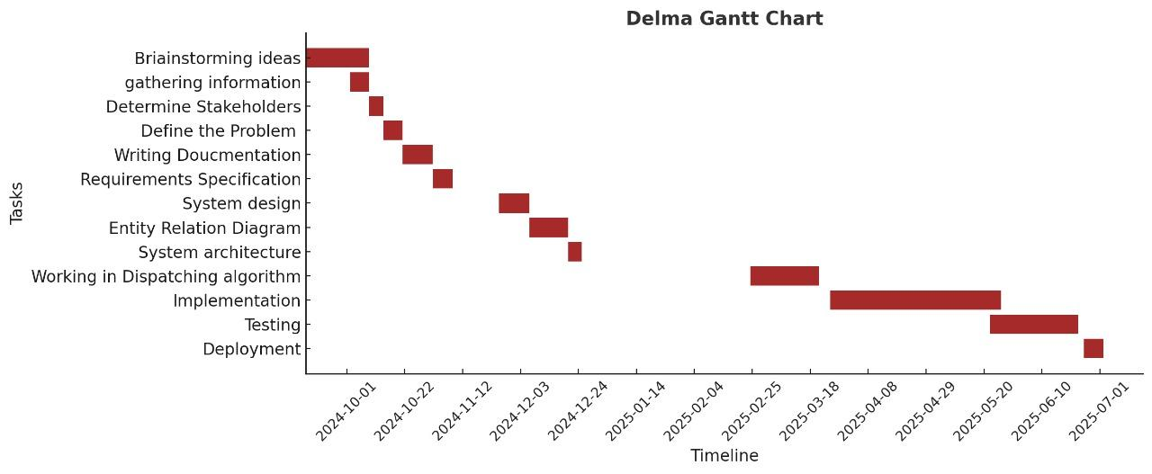

Figure 2. Delima Gantt Chart

## **1.5 Project Development Methodology**

The DELIMA project rigorously adhered to an **Agile Development Approach**, specifically implementing the Scrum methodology. This choice was driven by the inherent complexities of modern software development, the need for flexibility in responding to evolving requirements, and the desire to deliver value incrementally. Scrum facilitated iterative development, allowing the project team to adapt to changes, incorporate feedback early, and maintain a strong focus on delivering a high-quality product that aligned with stakeholder needs.

The implementation of Scrum involved several key practices throughout the project lifecycle. **Requirements Gathering** was an ongoing, iterative process within this framework. It involved extensive research into existing last-mile delivery systems, including a comprehensive review of solutions such as Bosta, Talabat, and Roboost, to understand market best practices and identify areas for innovation. Concurrently, we engaged directly with key stakeholders—couriers, business owners, operation managers, and end customers—through interviews, workshops, and feedback sessions to collect detailed functional and non-functional requirements. This continuous engagement ensured that the platform was precisely tailored to real-world delivery challenges, improved user satisfaction, and supported the evolving operational goals of businesses of varying sizes. The collected requirements formed and refined the product backlog, which was prioritized for development in subsequent sprints.

Following the refinement of requirements, **System Design** was conducted iteratively within sprints. This phase focused on defining the architectural and detailed system design for the features selected for the current sprint. Activities included creating detailed Use Case Diagrams to model user interactions, Entity Relationship Diagrams (ERD) to define the database schema, and Sequence Diagrams to illustrate the flow of operations between system components. A key focus was on designing a scalable system architecture that supported modularity, high availability, and future expansion. Special attention was given to the design of a smart dispatching algorithm and zone-based courier assignment logic, which were critical for optimal route management and efficient resource allocation. These design artifacts were reviewed and refined continuously, ensuring they aligned with both technical feasibility and business objectives.

During the **Implementation** phase, both front-end and back-end components were developed in parallel within each sprint. The development team focused on building the features prioritized in the sprint backlog, such as real-time courier tracking, automated order dispatching, optimized routing algorithms, and mobile application functionalities for couriers and customers. The system logic was meticulously crafted to ensure fair order distribution among couriers, live monitoring of delivery zones, and flexible role-based access control for different user types, including store owners, operation managers, and couriers. Continuous integration practices were employed to frequently merge code changes, allowing for early detection and resolution of integration issues.

**Testing and Validation** were integral and continuous activities throughout the development lifecycle, not confined to a single phase. Comprehensive functional, integration, and performance testing were performed within and across sprints to ensure system reliability and robustness. Test cases were meticulously designed to cover critical scenarios, including real-time data synchronization across devices, mobile application stability under varying network conditions, and API responsiveness under load. Emphasis was placed on identifying and handling edge cases, such as the reassignment of orders due to courier unavailability, managing delayed deliveries, and addressing various courier unavailability scenarios. Non-functional testing specifically focused on validating system usability through iterative feedback loops, ensuring robust security measures were in place, and confirming high availability and performance under anticipated load conditions.

Finally, **Deployment and Delivery** were managed incrementally, with potentially shippable increments delivered at the end of each sprint. The system was deployed to a real-world environment through a continuous delivery pipeline, ensuring smooth performance and minimal downtime. This phase included the final optimization of backend services, seamless mobile application deployment to relevant app stores, and thorough database tuning for optimal performance. Crucially, usability testing sessions were conducted with actual end-users in live conditions to collect direct feedback on the interface's intuitiveness and the dispatching system's real-world performance, ensuring the solution met practical operational needs.

By following this well-structured and iterative Agile development methodology, DELIMA delivered a robust, scalable, and intelligent delivery management solution. Each stage ensured that the platform was optimized for performance, aligned with evolving user needs, and capable of addressing the growing complexity of last-mile logistics in the e-commerce age.

## **1.6 The Used Tools in the Project**

In Delima, we utilize a range of software (SW) and hardware (HW) tools to support the development, training, and deployment of our Delivery Management System. These tools are carefully selected to ensure optimal performance, scalability, and efficiency throughout the project lifecycle.

### **1.6.1 Software Tools (SW)**

In this project, we utilized a variety of software tools to effectively design, develop, and implement the Delma Delivery Management System across web and mobile platforms:

**Web Development**

**Front-end:**

Development Environment: Visual Studio Code

Technologies: React.js – used to build a fast, responsive, and modular single-page application for the dashboard.

**Back-end:**

Framework: Node.js with Express – served as the primary backend framework to handle API logic, routing, and server-side processing.

API Design: RESTful API endpoints were developed to support order dispatching, courier management, real-time tracking, and data synchronization.

**Database:**

PostgreSQL: Used as the relational database to store structured data such as users, orders, couriers, zones, and delivery metrics.

pgAdmin: Employed for database management, schema design, and query optimization.

**Version Control:**

GitHub: Utilized to manage source code, track development history, and facilitate collaboration between front-end and back-end developers.

**Mobile Development**

Flutter: used to build a cross-platform courier mobile application compatible with both Android and iOS.

Mobile IDEs: Android Studio and VSCode – employed for mobile UI development, debugging, and testing.

Device Features Integration: Google Maps SDK integrated for route visualization and location tracking; local notifications for order alerts.

**Hosting & Deployment**

**Backend Services**:

* **Web Service:** Handles all API endpoints, core business logic, and secure interactions. Deployed as a scalable **web service on Render.**
* **Database**: Backed by **PostgreSQL**, provisioned through **Render’s managed database service** —ensuring automated backups, high availability, and minimal operational overhead.
* **File Storage:** We use **AWS S3** as our system-level file store. All interactions occur through **pre signed URLs** to ensure secure, permissioned access for uploads and downloads.

**Frontend**

* Deployed as a **static site** and deployed to **Render** —leveraging global CDNs for fast delivery and low latency.
* The frontend interacts with the backend exclusively via **RESTful APIs**
* All file uploads and image rendering are handled using **secure URLs** r**eturned by the backend,** keeping storage logic abstracted and safe.

**Testing Tools:** Postman for API testing, Flutter DevTools for mobile debugging, and browser dev tools for frontend inspection.

### **1.6.2 Hardware (HW):**

Smartphones (Android & iOS): Used for testing the courier mobile application in real-world scenarios. The app was verified for responsiveness, GPS integration, and performance across different screen sizes and OS versions.

Laptops/Desktops: Primary development machines used by the team for designing, coding, debugging, and testing the web and mobile applications. Each system was equipped with minimum specifications of 8 GB RAM and modern multi-core CPUs to support efficient development workflows.

Web Browsers: Google Chrome and Firefox were utilized for testing the responsiveness and compatibility of the React-based web dashboard.

By leveraging these hardware tools, we ensured a robust and practical development and testing environment. Each device played a crucial role in simulating end-user scenarios, validating system functionality, and ensuring a seamless experience across platforms in the Delima Delivery Management System.

## **1.7 Report Organization**

This technical report on the DELIMA (Delivery Management System) project is structured into a series of chapters, each building upon the preceding one to provide a comprehensive and logical progression of information, from foundational concepts to detailed implementation.

**Chapter 1: Introduction** (This chapter) provides the overarching context for the DELIMA project. It delves into the motivation behind developing such a system, articulating the current market challenges, business opportunities, and technological drivers. It then precisely defines the problems that DELIMA aimed to solve, detailing current inefficiencies and stakeholder pain points. The chapter concludes by outlining the project's primary objectives, the proposed solution approach, and the expected outcomes. It also presents the project's time plan via a Gantt chart, elucidates the agile development methodology employed, and lists all software and hardware tools utilized.

**Chapter 2: Related Work** will provide a thorough literature review and competitive analysis. This chapter will explore existing research, academic papers, and commercially available delivery management systems. It will critically evaluate their strengths and weaknesses, identifying gaps in the DELIMA aimed to fill. This analysis will justify DELIMA's unique value proposition and position it within the broader landscape of logistics solutions.

**Chapter 3: System Analysis** will focus on the detailed requirements specification for the DELIMA system. This chapter will elaborate on both functional and non-functional requirements, translating business needs into precise technical specifications. It will also include use case diagrams to visually represent the interactions between various system stakeholders and the core functionalities of the system, providing a clear understanding of user interactions.

**Chapter 4: System Design** will present the architectural blueprint of the DELIMA system. This chapter will detail the overall system architecture, including the separation of frontend and backend components, and how they interact. It will feature class diagrams to illustrate the relationships between key entities, sequence diagrams to depict the flow of operations for critical processes, and an Entity-Relationship Diagram (ERD) to showcase the database schema. Furthermore, it will include mock-ups or descriptions of the Graphical User Interface (GUI) to provide a visual representation of the user experience.

**Chapter 5: Implementation and Testing** will cover the practical aspects of the project's development and quality assurance. This chapter will detail the specific technologies and coding practices employed during the implementation phase. It will also outline the comprehensive testing strategy, including unit, integration, and user acceptance tests, providing examples of test cases and presenting the results of the testing efforts, thereby validating the system's functionality and reliability.

The content flow of this report is designed to be highly logical, progressing from a high-level understanding of the project's purpose to granular details of its design and implementation. Each chapter builds upon the information presented in the previous ones, ensuring a cohesive narrative. For instance, the problems identified in Chapter 1 directly informed the requirements specified in Chapter 3, which then dictated the design choices elaborated in Chapter 4. This structure ensures a seamless integration of technical specifications with business perspectives, providing a comprehensive and insightful overview of the DELIMA project.

# 

# **Chapter 2: Related Work**

To overcome the last mile delivery issues, businesses start using efficient delivery management systems that automate, streamline and optimize the last mile delivery process. There are some third-party solutions that help businesses to manage their delivery process efficiently, such as Talabat, Elmenus, Bosta, Noon, and Amazon, etc.These third-party solutions help businesses to manage their delivery process by providing couriers, take the product from the shop or store and deliver it to customers’ hands. combining insights from various studies and highlighting the methodologies, advancements, and differences between current research and our project.

## 2.1 The Existing Solutions:

To address last-mile delivery challenges, many businesses adopt delivery management platforms that offer varying degrees of automation, tracking, and optimization. These platforms can be broadly categorized into:

* **Third-party logistics providers (3PLs)** – like Talabat or Bosta, which provide both software and their own courier networks.
* **Delivery SaaS tools** – like Circuit and OptimoRoute, which help businesses optimize internal fleets without providing couriers.
* **AI-driven automation platforms** – like Roboost, that focus on smart dispatching and data-driven performance enhancements.

Below is an overview of the most relevant solutions:

#### **1. Roboost *(AI-Powered Delivery Automation – Egypt, MENA)***

**Overview:** Roboost is a cloud-based logistics automation platform targeting businesses in the MENA region. It uses artificial intelligence to optimize delivery performance, reduce delays, and streamline operations.

**Key Features:**

* AI-powered dispatching
* Real-time GPS tracking of couriers
* Delivery performance analytics
* Fleet utilization insights

**Strengths:**

* Strong automation and data analysis tools
* Designed for high-volume delivery workflows
* Localized for Arabic-speaking markets

**Limitations:**

* Limited support for long-term scheduling (e.g., multi-day routes)
* Enterprise-level pricing may not suit small businesses

#### **2. Circuit for Teams *(Route Optimization – Global)***

**Overview:** Circuit is an easy-to-use delivery route planner built primarily for courier teams and SMBs. It focuses on reducing delivery time through efficient routing.

**Key Features:**

* Route optimization with time windows
* Mobile courier app with proof-of-delivery (POD)
* Estimated time of arrival (ETA) notifications
* Team and task assignment

**Strengths:**

* User-friendly interface, minimal setup time
* Effective for smaller delivery teams
* Mobile app is intuitive and reliable

**Limitations:**

* Lacks real-time dispatch automation
* Limited analytics capabilities
* Not designed for complex logistics operations

#### **3. OptimoRoute *(Advanced Route & Schedule Planning – Global)***

**Overview:** OptimoRoute offers enterprise-level logistics planning, optimized for delivery, field service, and repair operations.

**Key Features:**

* Multi-day route planning
* Order prioritization and load balancing
* Route constraints (e.g., vehicle type, shift time)
* Rich analytics and exportable reports

**Strengths:**

* Highly customizable scheduling
* Scales well for large operations
* Good for dispatchers needing strict planning rules

**Limitations:**

* Steeper learning curve
* Setup complexity may overwhelm small businesses
* Less focus on mobile-first experience

#### **4. Bosta *(Courier Management as a Service – Egypt)***

**Overview:** Bosta is a last-mile delivery company that offers its own courier fleet and tracking dashboard, aimed at local businesses and e-commerce platforms.

**Key Features:**

* Courier pickup and delivery
* Shipment status tracking
* Cash on delivery (COD) support
* Delivery performance analytics

**Strengths:**

* Fully managed service—no need to hire couriers
* Focused on SMEs in Egypt
* Simple to integrate with online stores (e.g., Shopify, WooCommerce)

**Limitations:**

* Less flexible for businesses with internal delivery teams
* No control over courier performance
* Limited ability to customize delivery workflows

#### **5. Talabat / Elmenus / Noon *(Food & Retail Aggregators – Regional Giants)***

**Overview:** These platforms act as both marketplaces and delivery enablers. Businesses list their products, and the aggregator manages everything from customer orders to last-mile delivery using its own logistics.

**Key Features:**

* Complete end-to-end customer ordering
* Aggregator-managed courier fleets
* Promotions and customer loyalty programs
* Mobile apps for customers and couriers

**Strengths:**

* High traffic and marketing reach
* Simple setup for vendors
* Real-time delivery tracking for customers

**Limitations:**

* High commission fees (20–35%)
* Limited business control over branding, delivery, or customer data
* Not suitable for businesses wanting internal delivery operations

## 

## 

## 

## 

## ***The main differences between Delma and related work***

|  |  |  |  |  |
| --- | --- | --- | --- | --- |
| **Feature** | **Delma** | **Roboost** | **Circuit** | **OptimoRoute** |
| **Focus** | Easy to use Delivery automation and route optimization | AI-powered delivery automation | Route optimization for couriers | Advanced logistics route planning |
| **Ideal Users** | Small, mid and large businesses | Businesses in MENA and enterprises | small businesses | Large-scale logistics and service teams |
| **Route Optimization** | ✔ | ✔ | ✔ | ✔ |
| **Automated Dispatching** | ✔ | ✔ | ✗ | ✔ |
| **Real-Time Tracking** | ✔ | ✔ | ✔ | ✔ |
| **multi-day scheduling** | ✗ | ✗ | ✔ | ✔ |
| **Analytics and AI Insights** | ✔ | ✔ | ✗ | ✔ |

## 2.2 Comparing Our Presented Approach to Previous Work:

As described in the introduction, Delma is software that helps businesses to manage their own couriers to enhance efficiency and reliability. While Existing solutions manage delivery process using their own couriers.

**Comparison shows the differences before and after using Delma**

|  |  |  |
| --- | --- | --- |
| **Aspects** | **before** | **after** |
| Automation | No | Yes |
| visibility | limited | Real-time tracking |
| delays | high | minimized |
| Resource utilization | low | maximized |
| cost | high | low |

# **Chapter 3: System Analysis**

This chapter details the comprehensive system analysis conducted for the DELIMA project, outlining the functional and non-functional requirements that governed its development. The specifications presented herein were derived from extensive stakeholder engagement and a thorough understanding of the technical architecture and implementation details. This chapter also provides a detailed use case analysis, illustrating the interactions between various system actors and the core functionalities of the DELIMA system.

## **3.1 Project Specification**

The DELIMA project's specifications were meticulously defined, encompassing both the explicit functionalities the system delivered and the underlying quality attributes that ensured its performance, security, and usability. These specifications were directly informed by the actual code implementation and the chosen technology stack.

### **3.1.1 Functional Requirements**

The functional requirements defined the specific behaviors and functionalities that the DELIMA system provided to its users. These were directly implemented in the system's codebase, ensuring that all defined features were operational and met the project's objectives.

##### **Owner Role Functional Requirements**

The Owner role possessed overarching control and visibility across the entire DELIMA ecosystem, managing multiple branches and critical operational parameters.

* **Branch and Stock House Overview:** The Owner was able to view all branches and their associated stock houses within the system. This overview included real-time data on orders, couriers, defined zones, and configured delivery fees for each location.
* **Global Data Modification:** The Owner had the capability to modify core data across all branches and stock houses. This included adding new branches and stock houses, editing existing details, or deleting them as required.
* **Order Overview:** The Owner could view all orders across all branches in real-time. The system provided robust filtering and sorting capabilities, allowing for detailed analysis of order flows.
* **Order Assignment and Modification:** The Owner possessed the authority to manually assign or reassign orders to couriers across different branches. They could also update the statuses of orders directly.
* **Courier Overview:** The Owner had a comprehensive view of all couriers registered across all branches, including their assigned zones, current active status, and capacity.
* **Courier Assignment and Creation:** The Owner was able to add new couriers to any existing branch and assign them to specific delivery zones or designated stock houses.
* **Zone Management:** The system provided the Owner with full control to create, modify, and delete delivery zones for any branch, ensuring flexibility in defining service areas.
* **Fee Configuration:** The Owner could set or adjust the delivery fee for each defined zone, allowing for dynamic pricing strategies.
* **Role Management:** The Owner was responsible for managing roles and permissions for operators and couriers, ensuring appropriate access levels.
* **Order Notes Overview:** The Owner had access to view all notes added by both operators and couriers across branches, including detailed reasons for order cancellations, providing valuable insights into operational issues.
* **Order Distribution:** The Owner could trigger the order distribution process for any specific branch or globally across all branches. This process optimized the distribution of orders based on various parameters such as courier availability, location, and load.
* **Distribution Adjustments:** Following the automated distribution process, the Owner retained the ability to manually adjust courier assignments, providing an override capability for specific operational needs.

##### **Operator Role Functional Requirements**

The Operator role focused on the day-to-day management of orders and couriers within their scope, with capabilities to oversee and adjust automated processes.

* **Orders Displaying:** The system displayed all orders sent to it that were pending delivery, providing a clear queue for operators.
* **Orders Sorting and Filtering:** Operators could sort orders by various criteria, including the number of units, total amount, and the time the order was made. Orders could also be filtered by their status, such as "assigned" or "pended."
* **Couriers Displaying:** The system displayed all couriers registered within the operator's scope, along with detailed information for each courier, including their current status and the number of assigned orders.
* **Couriers Sorting and Filtering:** Operators could sort couriers by metrics such as the number of assigned orders and filter them by status (e.g., "available," "not available").
* **Couriers' Management:** Operators had the ability to add new couriers, remove existing ones, and modify courier profiles within their designated branches.
* **Automated Order Assignment:** The system automatically assigned orders to couriers based on predefined algorithms and re-assigned them as necessary to optimize delivery efficiency.
* **Operator Override:** Operators could review the automated assignments made by the system and manually adjust them if needed, providing human oversight and intervention.
* **Report Generation:** The operator was able to generate various reports on orders, couriers, and overall system performance within their operational purview.
* **Zone Monitoring:** The operator could monitor delivery zones to assess courier coverage and the distribution of orders, identifying potential imbalances or areas needing attention.

##### **Admin Functional Requirements**

The Super User role held the highest level of administrative control, primarily focused on managing the overall system and shop accounts.

* **View List of All Shops:** Super Users had access to view a comprehensive list of all registered shops (stores) within the DELIMA system.
* **Manage Shop Accounts:** Super Users could create new shop accounts and update the details of existing shop accounts, including their status and configurations.
* **Act as Shop Moderator:** Super Users possessed the unique ability to act as moderators for specific shops, allowing them to access and exercise all privileges associated with that shop's Owner role, facilitating support and oversight.
* **Activate & Deactivate Shop:** While the system automatically activated or deactivated shops based on predefined conditions (e.g., subscription status, compliance), the Super User could manually override this status if required, providing ultimate control.

##### **Courier Role Functional Requirements**

The Courier role was designed for efficient on-the-go management of deliveries, providing necessary tools for task execution and communication.

* **View Assigned Orders:** Couriers could view a list of orders that had been assigned to them for delivery, typically through their mobile application.
* **Select Order:** The courier selected a specific order from their assigned list to view its detailed information and initiate actions related to that delivery.
* **Update Order Status:** Couriers were able to update the status of a selected order to "Picked Up," "En Route," "Delivered," or "Cancelled," providing real-time progress updates.
* **Mark Availability Status:** Couriers could mark themselves as "Available," "Unavailable," or "On Break," which influenced whether they received new order assignments.
* **Complete Delivery Round:** Couriers could notify the system when they had completed a delivery round, indicating their readiness for new assignments or a change in their status.
* **View Optimized Routes:** Couriers could view optimized routes for a selected order, leveraging the system's routing algorithms for efficient navigation.
* **Report Delivery Issues:** Couriers were able to report problems encountered during deliveries for a specific order, such as customer unavailability, address issues, or vehicle breakdowns.

### 

### 

### 

### 

### 

### **3.1.2 Non-Functional Requirements (Based on Implementation)**

Non-functional requirements specified the quality attributes of the DELIMA system, ensuring its robustness, efficiency, and user satisfaction. These were critical for the system's long-term success and were directly addressed during implementation.

##### **Usability**

The DELIMA system was designed with a strong emphasis on user-friendliness and a minimal learning curve. The user interface was intuitive and responsive, ensuring that dispatchers and drivers could learn to use the system quickly and easily from their first interaction. This included a clean dashboard, straightforward navigation, and clear icons. Given that drivers primarily used mobile devices, the application was optimized to work seamlessly on various screen sizes, providing a consistent and efficient experience across platforms. The user experience was prioritized to be smooth and efficient for all roles.

##### **Performance**

The system demonstrated a robust ability to handle an increasing number of deliveries, users, and API requests without degradation in performance. Fast response times were a critical achievement, especially for real-time tracking and route optimization, which consistently did not exceed 2 seconds. The mobile applications were optimized for low battery and data consumption, ensuring efficient operation on courier devices throughout their shifts.

##### **Security**

Security was paramount in DELIMA's design and implementation. The system extensively used secure protocols such as HTTPS/TLS for all data transmission, encrypting communication between clients and servers. Token-based authentication, specifically JWT (JSON Web Token), was implemented for API access, providing a secure and stateless method for verifying user identities and authorizing requests. The system also adhered to principles aligned with ISO 27001, focusing on information security management best practices. Password hashing using bcrypt was implemented to protect user credentials.

##### **Availability**

The DELIMA system was engineered for high availability, ensuring that it was completely operational and delivered services when requested at least 98% of the time. This was achieved through redundant infrastructure, automated failover mechanisms, and continuous monitoring, minimizing downtime and ensuring consistent service delivery.

##### **Maintainability**

Maintainability was a core consideration during development to ensure the system could be efficiently updated and managed. The architecture and codebase were designed to minimize the time required for a solution or component to be fixed, changed to increase performance or other qualities, or adapted to changing requirements. A key metric for this was the Mean Time To Restore the System (MTTRS) following a system failure, which was targeted and achieved to be no greater than 10 minutes. This MTTRS included all corrective maintenance time and any associated delay time, reflecting a highly resilient and easily recoverable system.

## **3.1 Use Case Diagram**

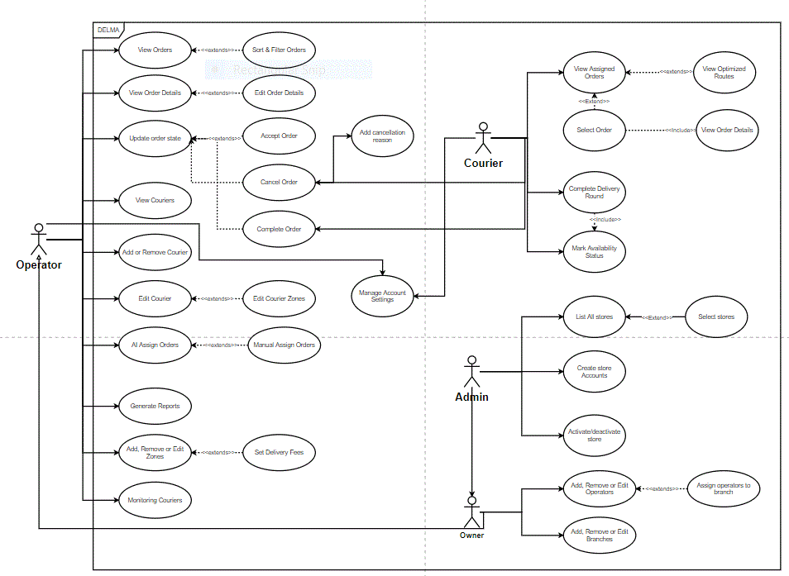

Figure 3. use case diagram

# **Chapter 4: System Design**

This chapter outlines the architecture of the Delma system, which integrates intelligent dispatching algorithms, real-time tracking, and modular web and mobile technologies to optimize last-mile delivery. By leveraging zone-based courier distribution and automated order assignment, Delma ensures efficient resource utilization and reduced delivery delays.

Delma features a responsive web dashboard for business owners and operators, alongside a dedicated mobile application for couriers to manage orders and routes. The backend, built with Node.js and PostgreSQL, handles data processing and real-time synchronization, ensuring seamless coordination between system components.

This chapter presents an overview of the design behind our delivery management solution.

## **4.1 System Architecture**

Figure 4. System Architecture

## 

## 

## 

## **4.2 System Component Diagram**

## 

Figure 5. Component Diagram

## 

## 

## 

## 

## 

## **4.3 System Class Diagram**

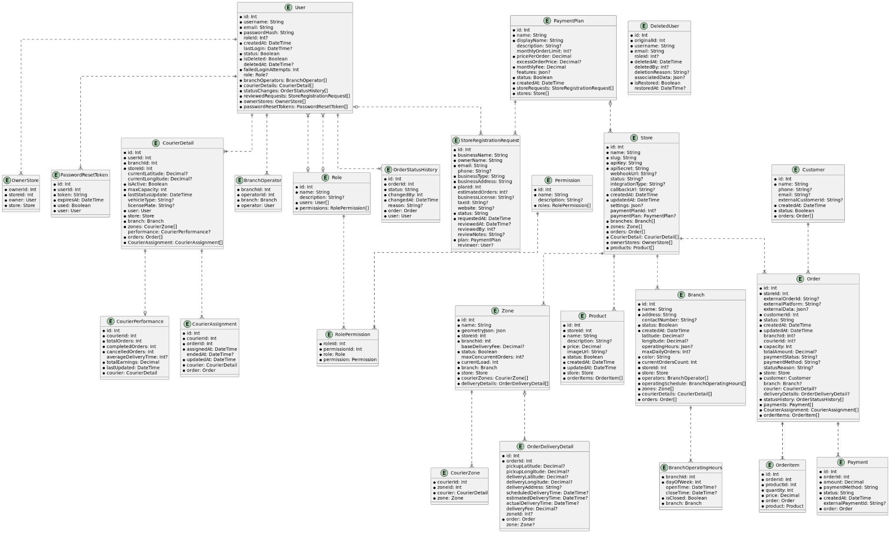

Figure 6. class diagram

## 

## 

## **4.4 Sequence Diagrams**

### 4.3.1 Admin interactions:

**1.activate/deactivate Store:**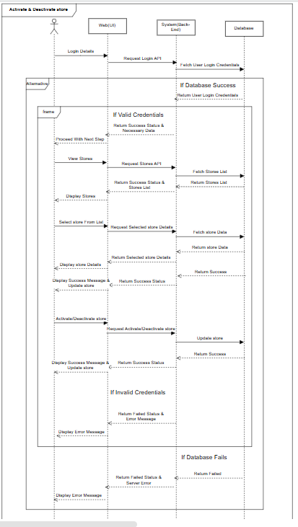

Figure 7. activate/deactivate store

**2.view stores:** 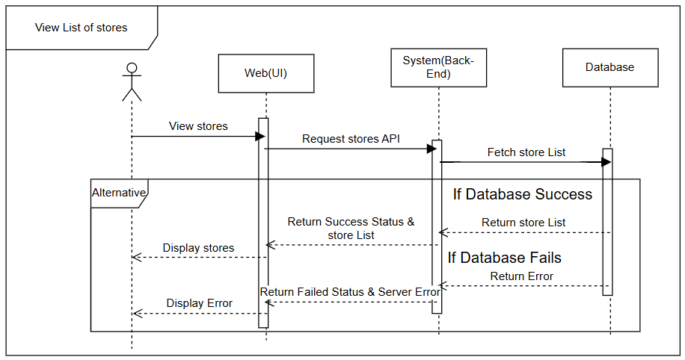

Figure 8. view stores

### 4.3.2 Courier interactions:

1. **Change order status:**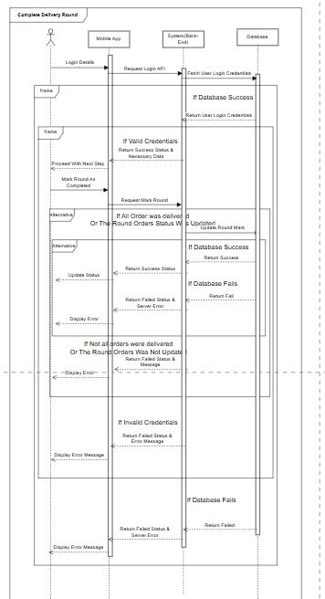

Figure 9. change order status

1. **Mark availability:** 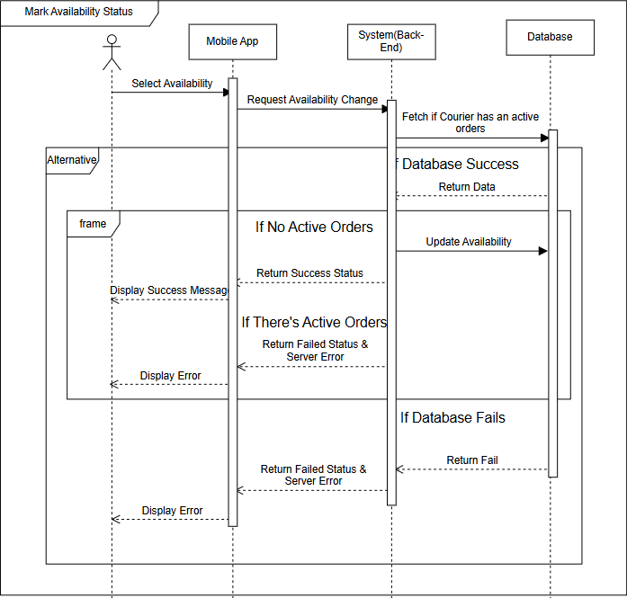

Figure 10. mark availability

1. **view order details:** 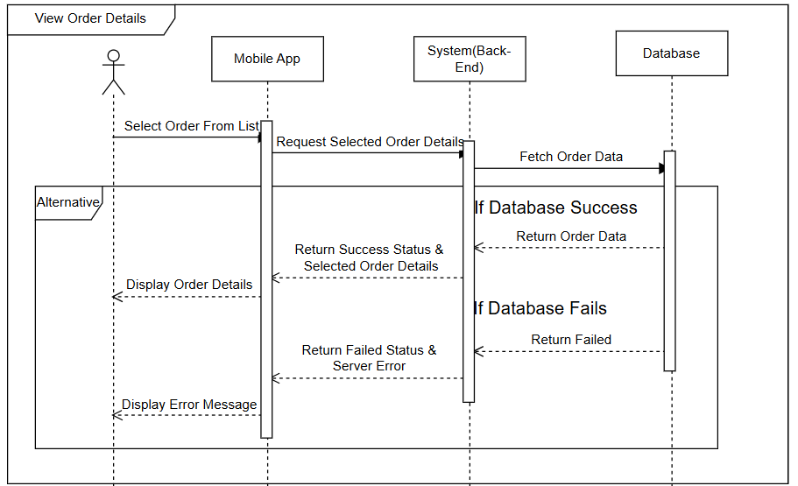

Figure 11. view order details

### 4.3.3 Owner interactions:

1. **Add branches:** 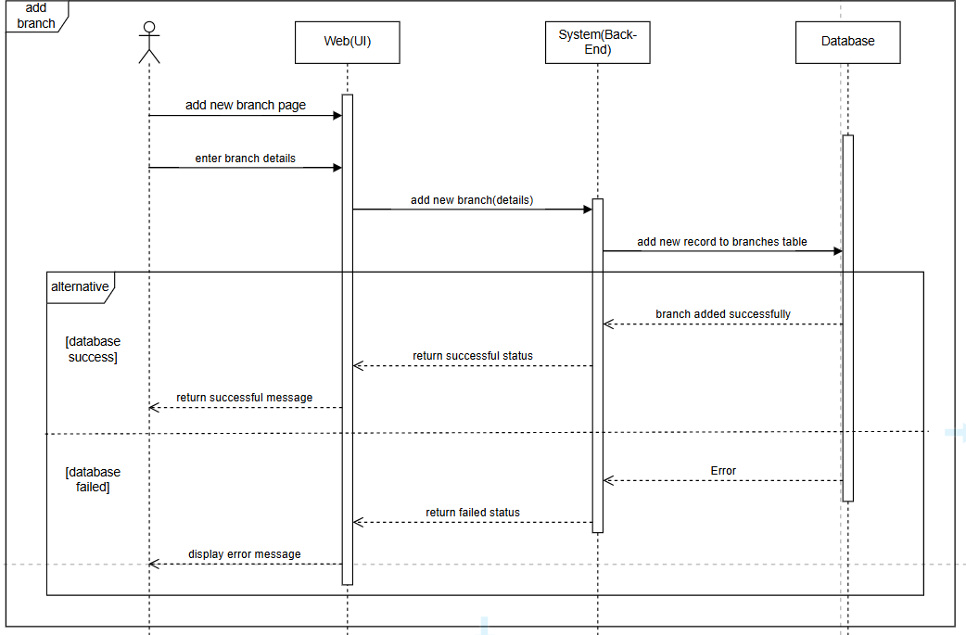

Figure 12. add branches

1. **Remove branches:** 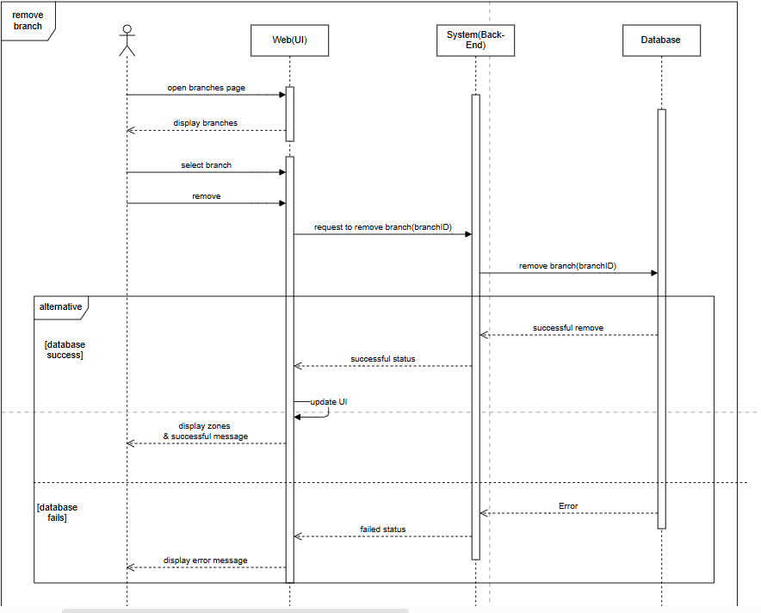

Figure 13. remove branches

1. **Edit branches:** 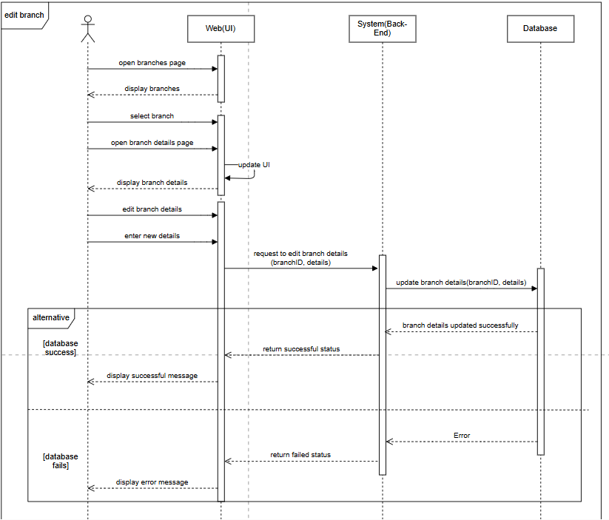

Figure 14. edit branches

### 4.3.4 Operator interactions:

1. **Add couriers:** 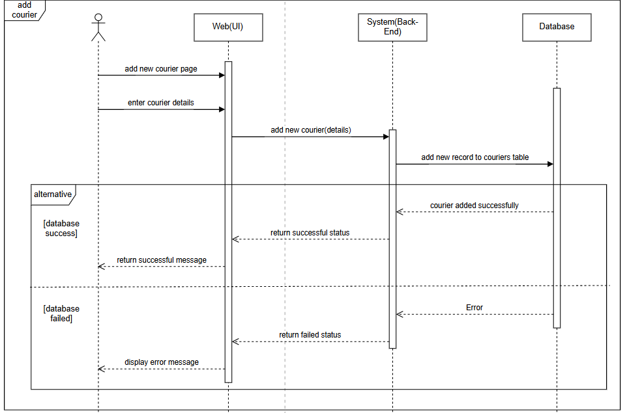

Figure 15. add couriers

1. **delete couriers:** 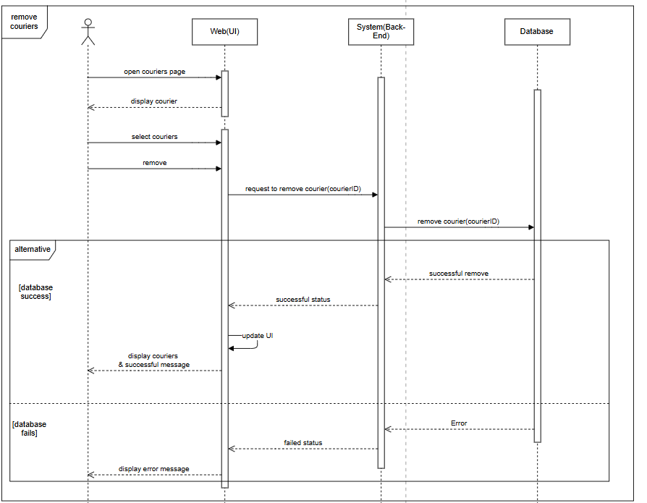

Figure 16. delete couriers

1. **Update Order:** 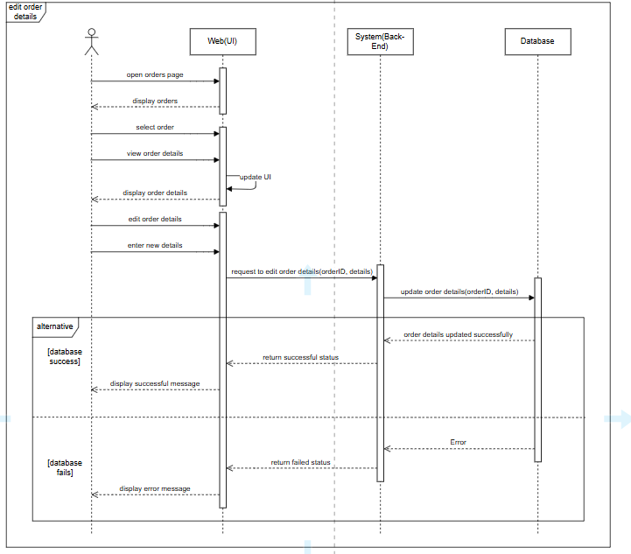

Figure 17. update order

**4.5 Project ERD**

## 

Figure 18. ERD diagram

## **4.6 System GUI Design**

### 4.6.1 Mobile Application:

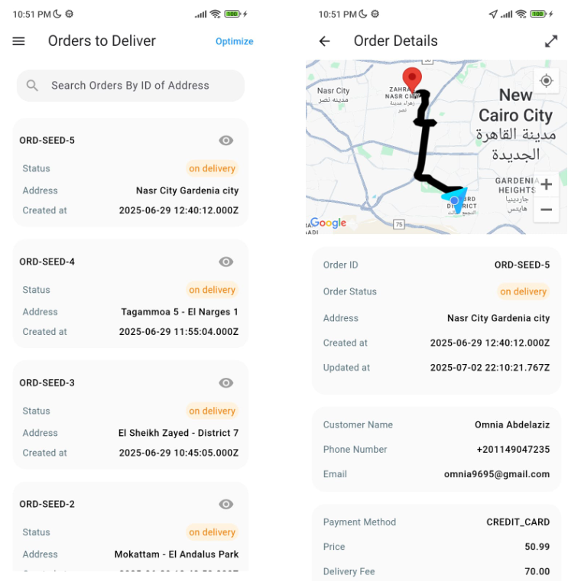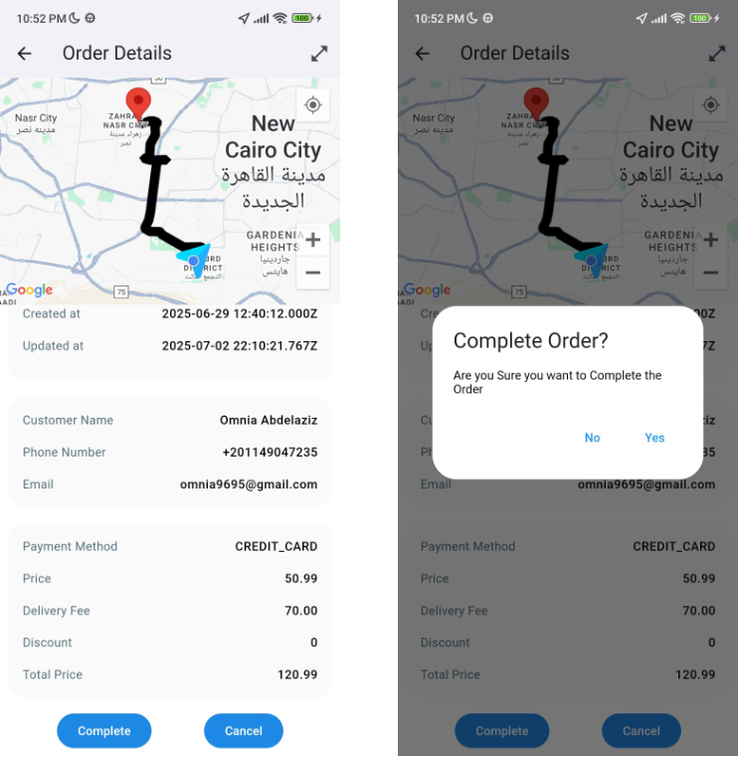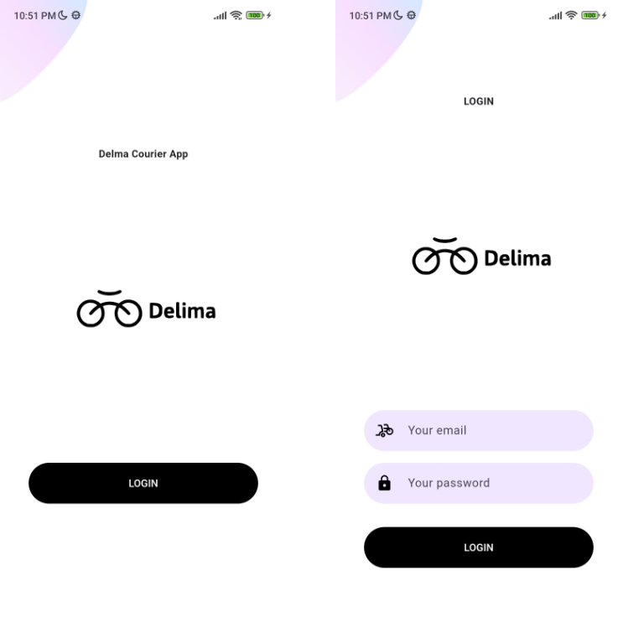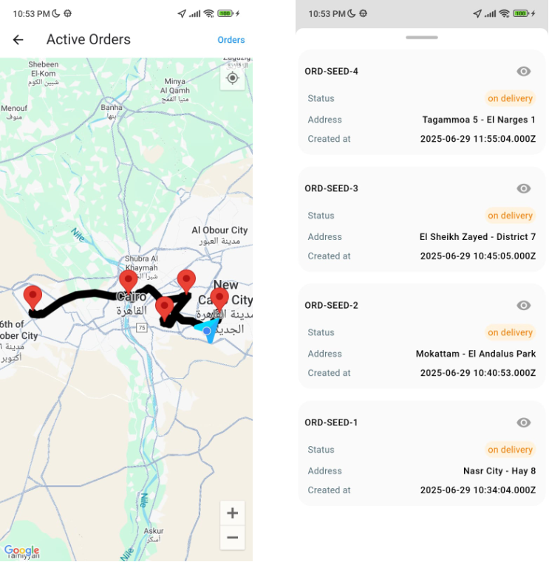

Figure 19. Orders list

Figure 20. complete Order

Figure 21. Login

Figure 22. map View

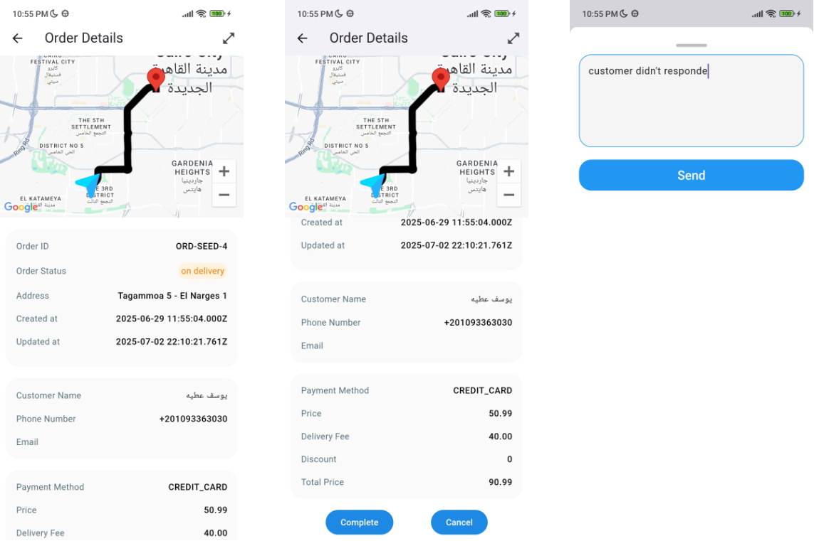

Figure 23. Cancel Order

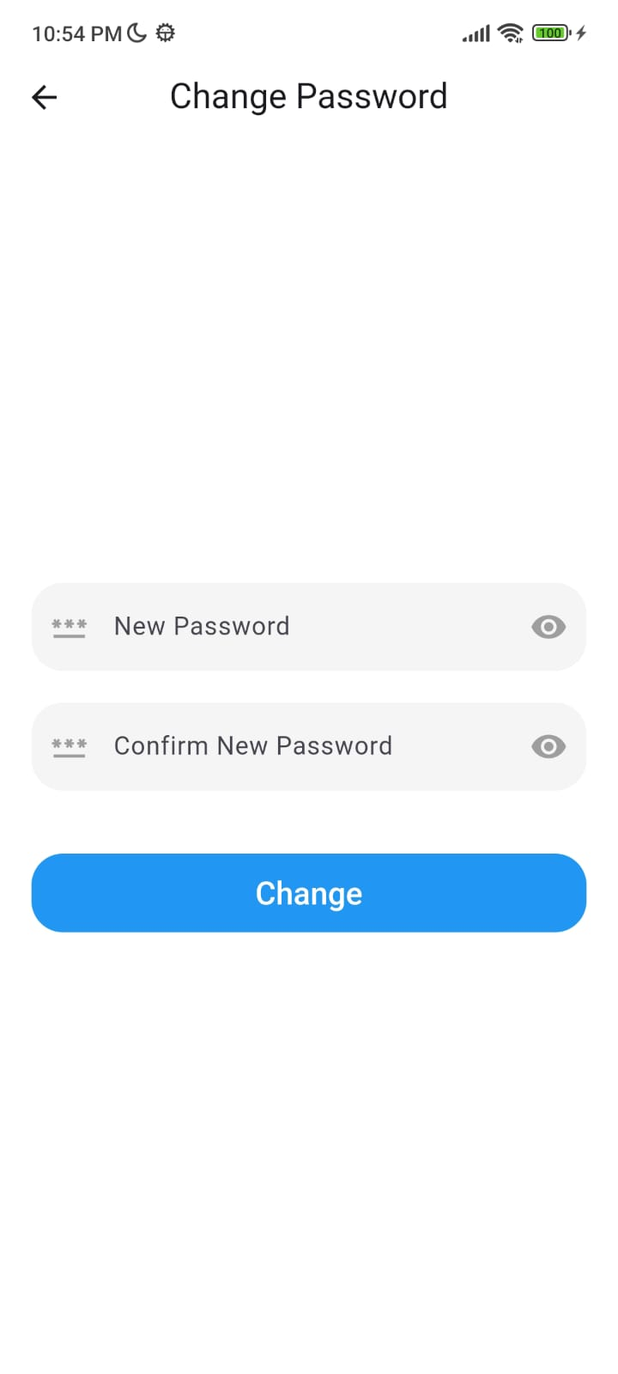

Figure 24. Chained Orders

Figure 25. change password

### 4.6.2 Website:

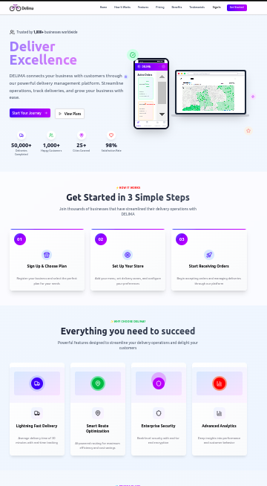

Figure 26. home page

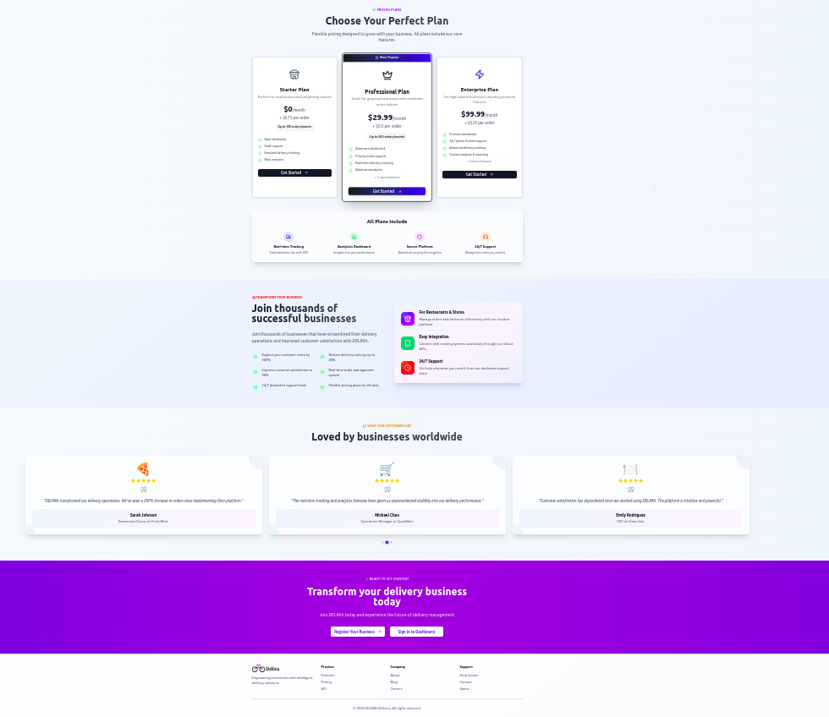

Figure 27. more of home page

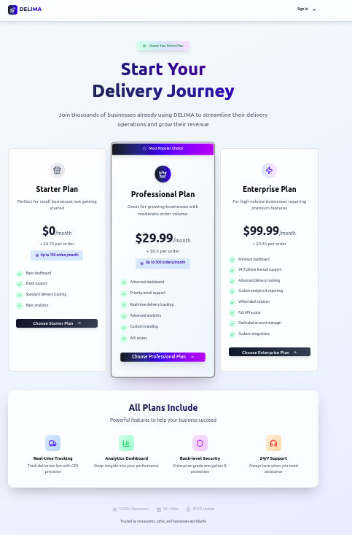

Figure 28. payment plans

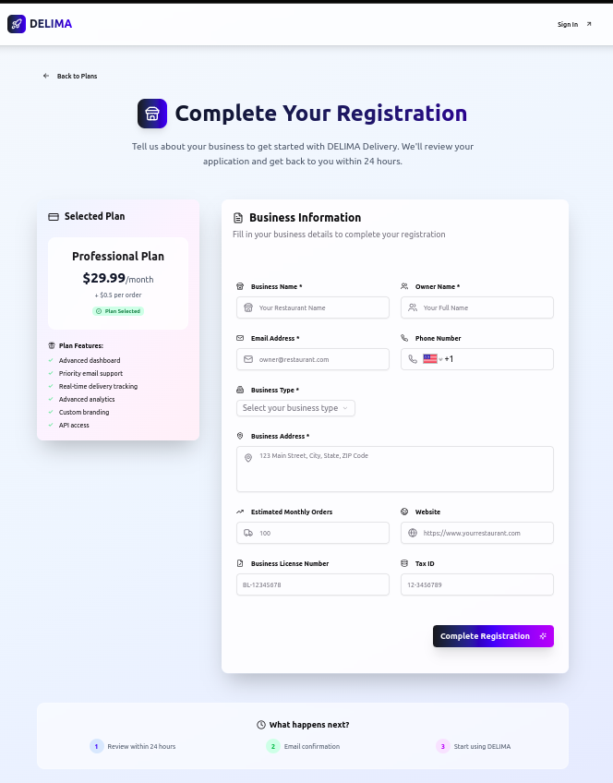

Figure 29. registration

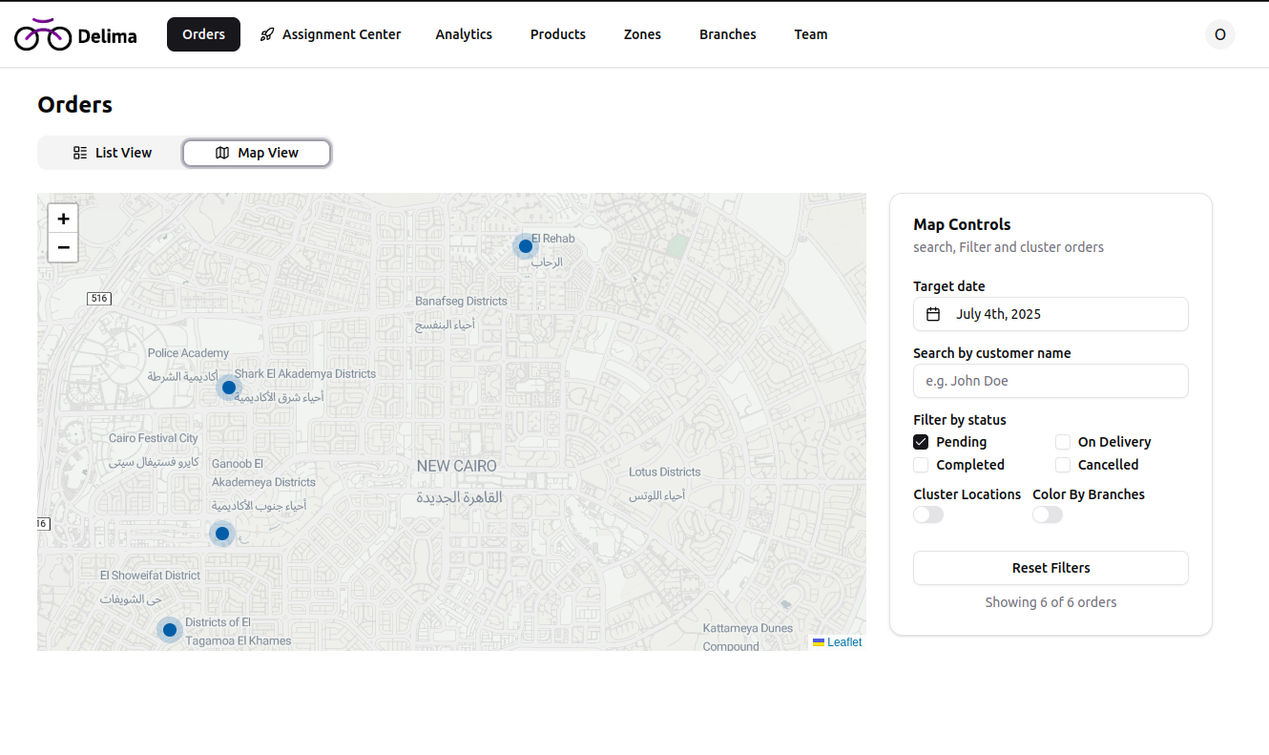

Figure 30. view orders on map

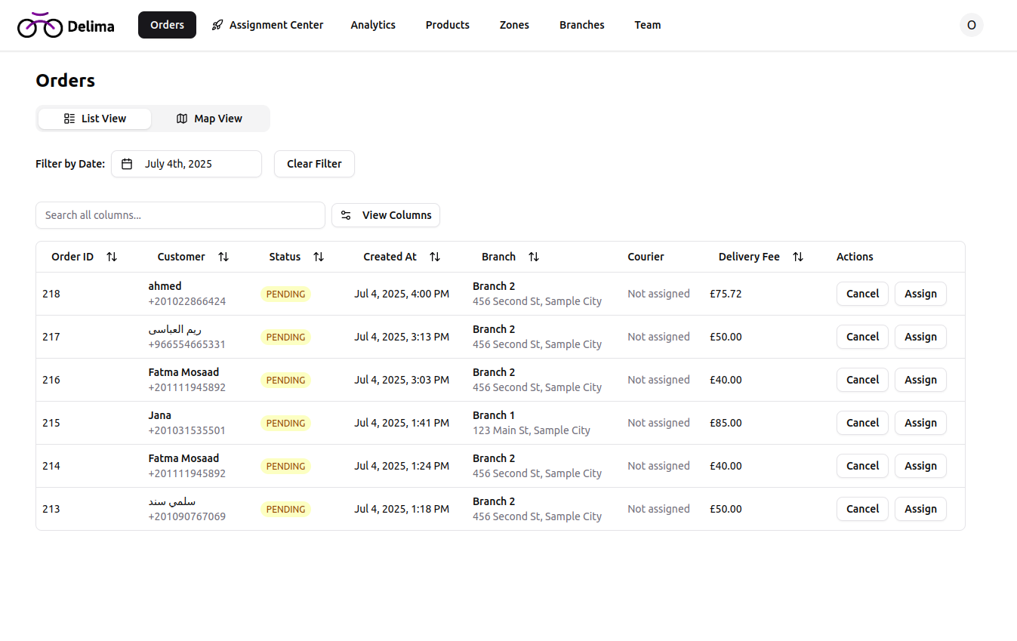

Figure 31. list of orders

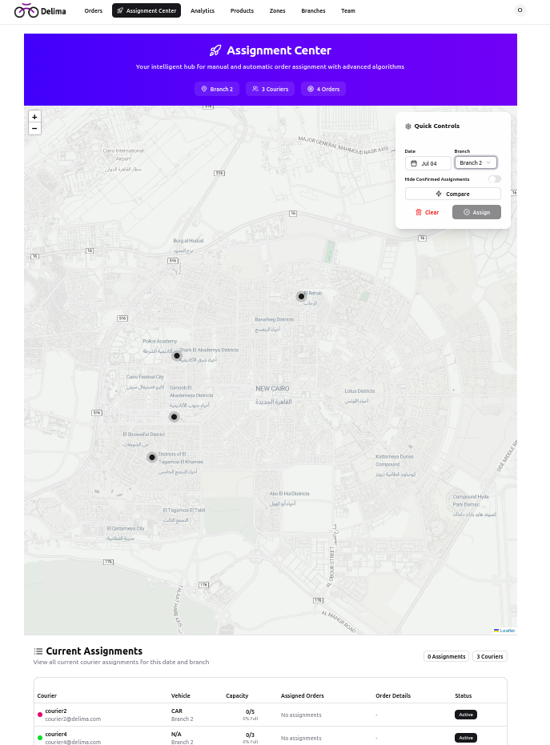

Figure 32. Assignment center

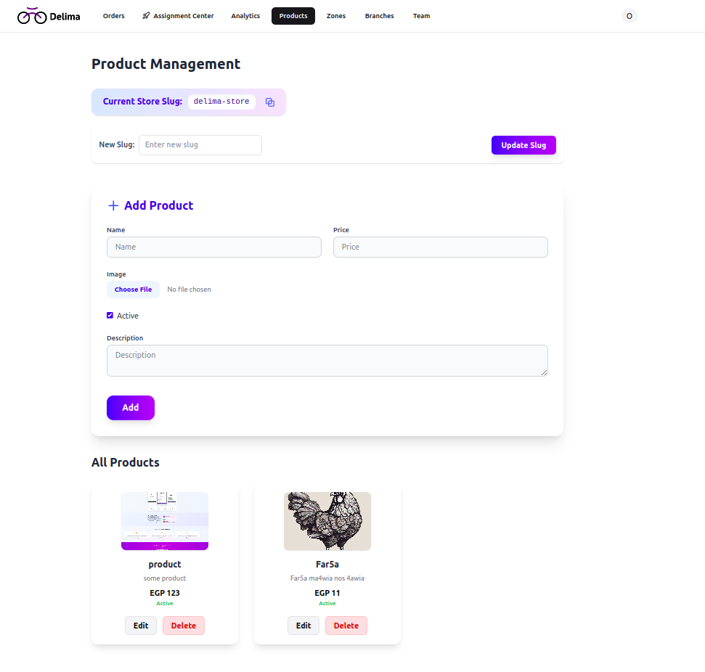

Figure 33. product managment

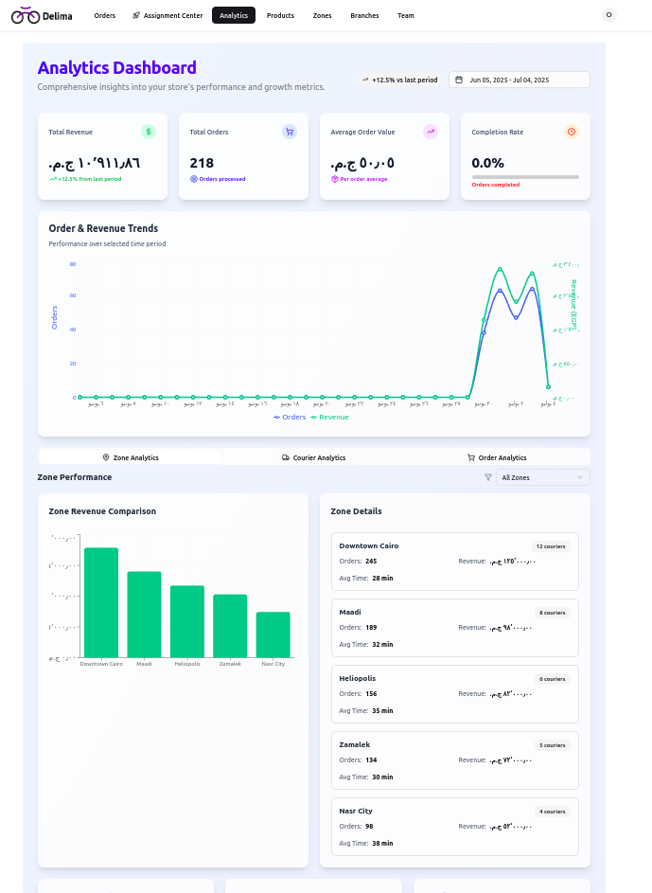

Figure 34. analytics

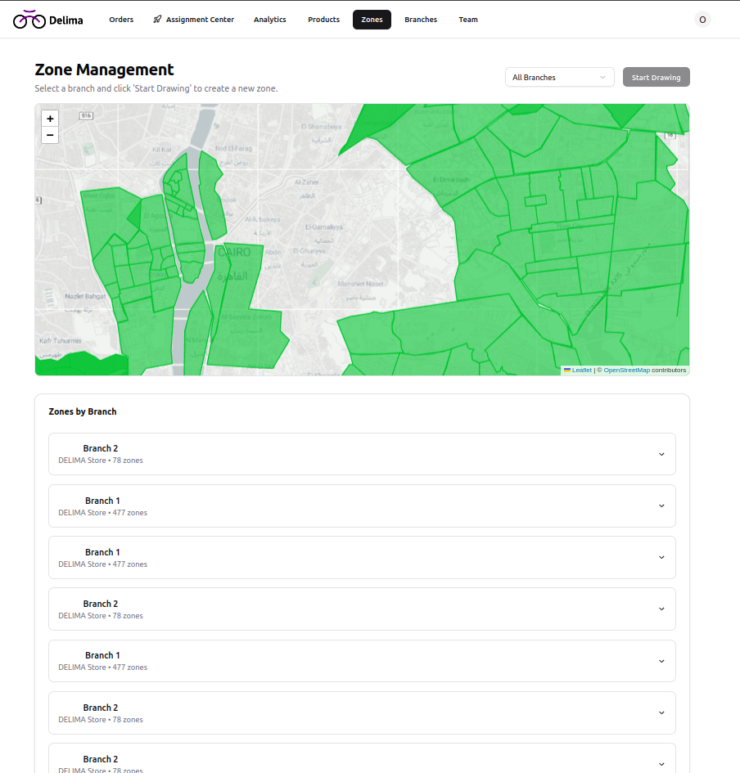

Figure 35 zone managment page

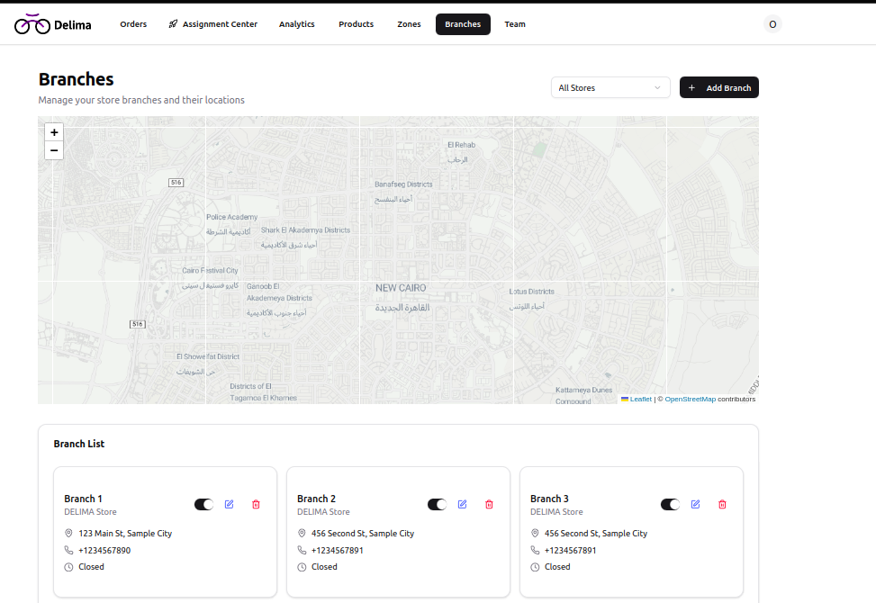

Figure 36. branches managment

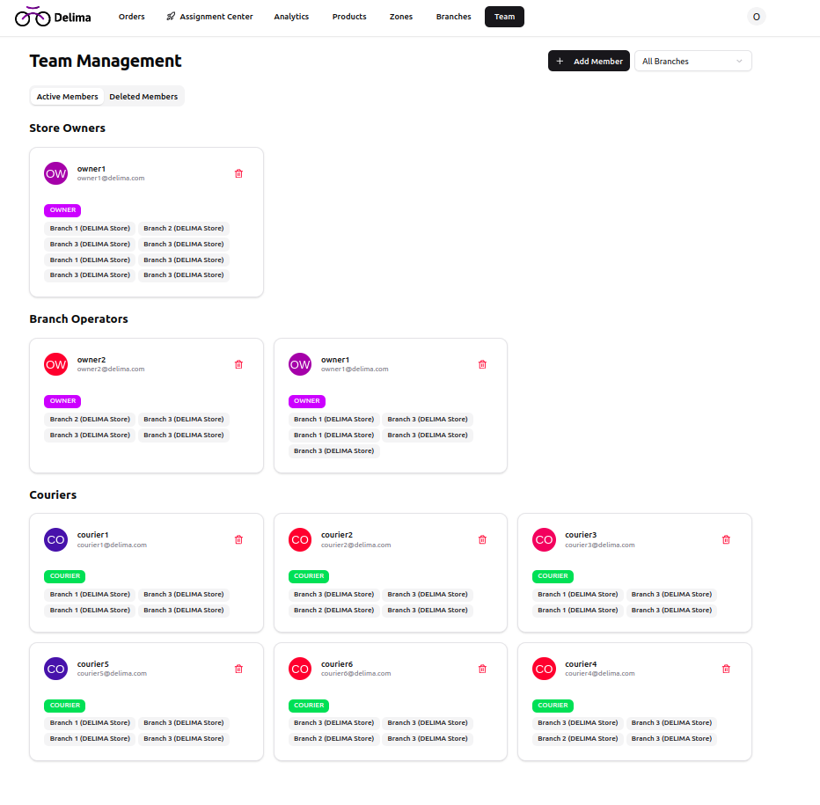

Figure 37. team managment page

# 

# **Chapter 5: Implementation and Testing**

## 5.1 implementation

### 5.1.1 Web implementation

This section outlines the architecture, technologies, and key features of the DELIMA delivery management system, along with the challenges encountered and their solutions.

### **System Architecture**

The DELIMA delivery management system follows a modern **client-server architecture** with a clear separation of concerns, ensuring scalability, maintainability, and robust performance.

**Key Architectural Components:**

* **Frontend Layer:** A Single Page Application (SPA) built with **React** and **TypeScript**, responsible for the user interface and real-time interactions.
* **API Layer:** A **Node.js** backend powered by **Express.js**, providing a robust REST API for business logic, data processing, and authentication.
* **Database Layer:** **PostgreSQL** serves as the primary data store, managed efficiently with **Prisma ORM** for object-relational mapping.
* **Authentication:** Implemented using **JWT (JSON Web Tokens)** with comprehensive role-based access control (RBAC).
* **Real-time Features:** Utilizes **WebSockets** to enable live updates and real-time data synchronization across the system.
* **File Storage:** Integrated with **AWS S3** for secure and scalable handling of file uploads.

**Data Flow:**

The system's data flow is designed for efficiency and responsiveness:

1. **Client Requests:** Initiated by the frontend application.
2. **API Gateway:** Routes requests to appropriate backend services.
3. **Route Handlers:** Process incoming requests.
4. **Controllers:** Manage application logic and interact with services.
5. **Services:** Contain core business logic and interact with the database.
6. **Database:** Stores and retrieves all system data.

Real-time updates are facilitated through WebSocket connections, ensuring immediate propagation of critical information. File uploads are directly handled via AWS S3 integration for optimized performance and security.

### **Tools and Technologies Used**

The DELIMA system leverages a modern and comprehensive technology stack to deliver a high-performance and scalable solution.

**Frontend Technologies:**

* **Framework:** React 18 with TypeScript for robust and type-safe development.
* **Build Tool:** Vite for rapid development and optimized production builds.
* **Styling:** Tailwind CSS 4.1, coupled with a custom design system, for efficient and consistent UI styling.
* **UI Components:** Radix UI primitives, custom-styled for flexible and accessible UI elements.
* **State Management:** React hooks and Context API for efficient and predictable state management.
* **Routing:** React Router DOM v7 for declarative navigation.
* **Forms:** React Hook Form with Zod validation for streamlined form handling and data validation.
* **Maps:** React Leaflet with clustering capabilities for interactive map visualizations.
* **Charts:** Recharts for dynamic and insightful analytics visualization.
* **HTTP Client:** Axios for making efficient API calls.

**Backend Technologies:**

* **Runtime:** Node.js with the Express.js framework for building scalable server-side applications.
* **Language:** JavaScript with TypeScript support for enhanced code quality and maintainability.
* **Database:** PostgreSQL 15, managed with Prisma ORM for seamless database interactions.
* **Authentication:** JWT tokens for secure authentication, with bcrypt for robust password hashing.
* **File Storage:** AWS S3 for secure and scalable storage of documents and images.
* **Email:** Nodemailer for sending automated email notifications.
* **Algorithms:** ML k-means for advanced delivery optimization.
* **Validation:** Zod for schema validation across API endpoints.

**Development Environment:**

* **Version Control:** Git with GitHub for collaborative code management.
* **Package Manager:** npm for managing project dependencies.
* **Code Quality:** ESLint and Prettier for maintaining code consistency and quality.
* **Database Management:** Prisma Studio and Adminer for database inspection and management.
* **Containerization:** Docker Compose for consistent local development environments.

**Infrastructure:**

* **Database:** PostgreSQL hosted on a cloud provider for high availability and performance.
* **File Storage:** Dedicated AWS S3 bucket for all file storage needs.

### **Modules and Components**

The DELIMA system is structured into distinct modules and components, enhancing modularity and maintainability.

**Frontend Modules:**

* **Authentication Module** (/src/pages/AuthPages/):
  + Handles user login/logout functionality.
  + Manages password reset processes with email verification.
  + Implements role-based route protection to secure access.
* **Order Management Module** (/src/pages/Orders/):
  + Facilitates order creation, viewing, and status tracking.
  + Provides real-time order updates for users.
  + Includes an assignment center for efficient courier allocation.
* **Store Management Module** (/src/pages/stores/):
  + Enables store registration and configuration.
  + Manages branch details with geolocation capabilities.
  + Supports product catalog management.
* **Analytics Module** (/src/pages/AnalyticsPage/):
  + Visualizes key performance metrics.
  + Generates delivery efficiency reports.
  + Provides revenue and order analytics.
* **Team Management Module** (/src/pages/Team/):
  + Manages courier and operator profiles.
  + Handles role and permission assignment.
  + Tracks individual and team performance.

**Backend Modules:**

* **Authentication Controller** (/controllers/authController.js):
  + This controller manages user authentication. It takes the user's email and password, verifies them against stored credentials (which are securely hashed), and if successful, generates a JSON Web Token (JWT) containing user ID and role. This token is then sent back to the client, typically as an HTTP-only cookie, for secure, subsequent requests. It also includes error handling for invalid credentials and ensures secure token generation and transmission.
* **Order Management Controller** (/controllers/orderController.js):
  + Handles CRUD (Create, Read, Update, Delete) operations for orders.
  + Manages status tracking and order history.
  + Integrates with external systems via webhooks.
* **Courier Assignment Controller** (/controllers/courierController.js):
  + Implements advanced delivery optimization algorithms.
  + Enables real-time courier tracking.
  + Provides performance analytics for couriers.
* **Analytics Controller** (/controllers/analyticsController.js):
  + Aggregates business intelligence data.
  + Calculates key performance metrics.
  + Generates comprehensive reports.
* **Analytics Controller** (/controllers/analyticsController.js):

**Key Features Implementation:**

* **Delivery Optimization Algorithm:**
  + This feature utilizes K-means clustering to optimize delivery routes geographically. It fetches pending orders, extracts their delivery coordinates, and then applies the K-means algorithm to group them into efficient clusters. The system then uses this clustering information to assign orders to couriers based on proximity, aiming to minimize travel distance and balance workload. Robust error handling is included to manage cases with no orders or invalid coordinates.
* **Real-time Order Tracking:**
  + This functionality is built using WebSockets to provide live updates of order statuses. When a user connects, the system establishes a WebSocket connection. Any updates to order status or courier location are immediately broadcasted to all connected clients, ensuring that users see the most current information without needing to refresh their interface.
* **Role-based Access Control:**
  + This is implemented as a middleware function that checks user permissions before allowing access to specific routes or functionalities. After a user is authenticated, their role is determined. The authGuard middleware then verifies if the user's role matches the required role for the requested resource. If the roles do not match, access is denied, ensuring that users can only interact with parts of the system for which they have authorization.

### 

### **Challenges and Solutions**

During the development of the DELIMA system, several key challenges were identified and addressed with strategic solutions.

1. **Delivery Route Optimization Challenge:**
   * **Problem:** Efficiently assigning orders to couriers while minimizing travel distance and ensuring fair workload distribution.
   * **Solution:** Implemented a hybrid algorithm combining K-means clustering with Euclidean distance calculations. This approach leverages the ML k-means library for geographic clustering, calculates fairness and efficiency scores, and automatically selects the optimal algorithm based on order distribution patterns.
2. **Real-time Data Synchronization Challenge:**
   * **Problem:** Keeping order status synchronized across multiple users and devices in real-time.
   * **Solution:** Implemented robust WebSocket connections with a fallback to polling for environments where WebSockets might be restricted. This ensures real-time updates for critical status changes, provides optimistic UI updates for a better user experience, and includes mechanisms for conflict resolution during concurrent modifications.
3. **Scalable Database Design Challenge:**
   * **Problem:** Managing complex relationships between stores, branches, orders, and couriers while ensuring scalability and performance.
   * **Solution:** Designed a normalized database schema with **Prisma ORM**. This involved establishing proper foreign key relationships, implementing indexed queries for performance optimization, and utilizing soft delete patterns to maintain data integrity without permanent deletion.
4. **Multi-tenant Architecture Challenge:**
   * **Problem:** Supporting multiple stores with isolated data and configurations within a single system instance.
   * **Solution:** Implemented store-based routing and data isolation. This is achieved through URL-based store identification (e.g., /stores/:storeId/), coupled with middleware for store access verification and separate API endpoints tailored for each store's context.
5. **File Upload and Storage Challenge:**
   * **Problem:** Ensuring secure and scalable file storage for various documents and images.
   * **Solution:** Integrated with **AWS S3** using pre signed URLs. This allows for direct uploads to S3, enhancing performance and reducing server load. Secure access control is managed with temporary URLs, and automatic file cleanup and organization routines are in place.
6. **Performance Optimization Challenge:**
   * **Problem:** Achieving fast loading times for large datasets, particularly for orders and analytics reports.
   * **Solution:** Implemented a combination of pagination, caching, and optimized queries. This includes database query optimization with Prisma, frontend pagination for handling large lists, and memoized components for computationally expensive calculations to prevent unnecessary re-renders.

### **Assignment Algorithms and Optimization**

#### **Overview**

The DELIMA system implements sophisticated delivery optimization algorithms to efficiently assign orders to couriers while balancing multiple competing objectives: delivery efficiency, workload fairness, and operational constraints.

#### **Implemented Algorithms**

1. **Clustering-Based Assignment (K-means)**
   * **Approach:** This method utilizes K-means clustering to group orders geographically and assigns entire clusters to couriers.
   * **Process:** The system first groups delivery locations into clusters based on their geographic proximity. Each cluster is then assigned to the courier with the best capacity match, with a primary focus on balancing the workload among couriers rather than solely optimizing for minimum travel distance.
   * **Best For:** Scenarios with orders broadly spread across different geographic areas.
   * **Advantages:** Ensures fair workload distribution and reduces courier idle time.
   * **Limitations:** May not always achieve the absolute minimum total travel distance.
2. **Euclidean Distance Optimization**
   * **Approach:** This algorithm combines initial clustering with a distance-based post-processing step.
   * **Process:** It begins by performing an initial K-means clustering. After the initial assignment, it fills any remaining courier capacity by assigning the nearest unassigned orders, using Euclidean distance calculations to determine proximity.
   * **Best For:** Scenarios requiring both geographic clustering and precise distance optimization.
   * **Advantages:** Balances the benefits of clustering with effective distance minimization.
   * **Limitations:** More computationally intensive compared to pure clustering methods.
3. **Greedy Algorithm with Fairness Heuristics**
   * **Approach:** This is a sequential assignment approach that prioritizes fairness considerations.
   * **Process:** Each new order is assigned to the courier with the lowest current workload. Geographic proximity is considered as a secondary factor to refine the assignment. This method continuously aims to maintain workload balance throughout the assignment process.
   * **Best For:** Real-time assignment scenarios with dynamic order arrivals and frequent changes.
   * **Advantages:** Offers fast computation, consistently maintains fairness, and effectively handles dynamic operational scenarios.
   * **Limitations:** May not achieve global optimality in terms of overall efficiency.
4. **Min-Cost Max-Flow Approximation**
   * **Approach:** This method models the assignment problem as a network flow optimization, aiming for maximum efficiency.
   * **Process:** Orders are assigned to couriers by treating the problem as a flow network, where the goal is to maximize the flow (assignments) while minimizing the cost (e.g., travel distance or time). It prioritizes efficiency and throughput while strictly respecting courier capacity constraints.
   * **Best For:** Scenarios with tight capacity constraints and high efficiency requirements.
   * **Advantages:** Maximizes throughput and effectively handles complex capacity constraints.
   * **Limitations:** May sacrifice some degree of workload fairness for overall efficiency.

#### **Algorithm Selection Logic**

The system employs an intelligent algorithm selection mechanism that automatically chooses the most appropriate algorithm based on dynamic operational parameters:

1. **Order-to-Courier Ratio:**
   * **Low Ratio (≤ 2:1):** Prioritizes fairness, typically using a clustering algorithm to ensure equitable distribution.
   * **High Ratio (> 2:1):** Balances fairness and efficiency, opting for hybrid approaches that combine clustering with distance optimization.
2. **Geographic Spread Analysis:**
   * **High Spread (> 50 units):** Uses Euclidean optimization to maximize distance efficiency across a wide area.
   * **Low Spread (≤ 50 units):** Compares multiple algorithms and selects the best performer based on combined metrics, as the geographic spread is less of a differentiating factor.
3. **Capacity Constraints:**
   * **Tight Constraints:** Employs the Min-Cost Max-Flow algorithm for maximum throughput and efficient resource utilization.
   * **Flexible Constraints:** Allows for fairness-focused algorithms, as there is more room to balance workloads without compromising overall capacity.

#### **Comparison Metrics**

To ensure optimal algorithm selection and performance, the system uses a set of weighted comparison metrics:

1. **Fairness Score (40% weight):**
   * **Calculation:** Based on the standard deviation of courier workloads.
   * **Formula:** 1−(stdDev/maxPossibleStdDev)
   * **Range:** 0-1 (where 1 indicates a perfectly fair distribution).
   * **Purpose:** Ensures equitable workload distribution among couriers, preventing burnout or underutilization.
2. **Efficiency Score (60% weight):**
   * **Calculation:** Based on the total travel distance optimization.
   * **Formula:** 1−(totalDistance/maxPossibleDistance)
   * **Range:** 0-1 (where 1 indicates maximum efficiency).
   * **Purpose:** Minimizes fuel costs and delivery times by optimizing routes.
3. **Combined Score:**
   * **Formula:** 0.4×Fairness+0.6×Efficiency
   * **Purpose:** Provides a single, comprehensive metric for comparing and selecting the best-performing algorithm under current conditions. This is the primary decision criterion for algorithm selection.

#### **Performance Evaluation Framework**

The system continuously evaluates the performance of its algorithms through a robust framework:

1. **Geographic Spread Calculation:**
   * Measures the dispersion of delivery locations to inform algorithm selection (e.g., whether clustering or distance optimization is more critical).
   * Utilizes threshold-based decision-making for dynamic algorithm selection.
2. **Capacity Utilization Analysis:**
   * Tracks how effectively courier capacities are utilized.
   * Identifies underutilized or overburdened couriers, providing crucial insights for capacity planning and adjustments.
3. **Real-time Performance Monitoring:**
   * Tracks actual delivery times against estimated times.
   * Monitors courier satisfaction and workload balance.
   * Provides continuous feedback for algorithm parameter tuning and refinement.

#### **Algorithm Comparison Process**

1. **Multi-Algorithm Execution:**
   * Runs all applicable algorithms on the same dataset to gather comparative performance data.
   * Calculates performance metrics for each approach.
   * Compares results using standardized scoring based on the combined score.
2. **Context-Aware Selection:**
   * Considers current operational conditions and factors in historical performance data.
   * Adapts algorithm selection to changing business requirements and real-world scenarios.
3. **Continuous Learning:**
   * Tracks algorithm performance over time to identify trends and areas for improvement.
   * Adjusts selection criteria based on observed outcomes.
   * Incorporates feedback from couriers and customers to further refine the optimization process.

#### **Operational Considerations**

1. **Real-time Constraints:**
   * Algorithms must complete within acceptable time limits to support dynamic operations.
   * The system handles dynamic order arrivals and cancellations seamlessly.
   * Maintains system responsiveness even under high load conditions.
2. **Scalability Requirements:**
   * The system efficiently handles varying order volumes, from small local stores to large-scale operations.
   * It is designed to maintain performance and efficiency with growing data and user bases.
3. **Business Rule Integration:**
   * The algorithms respect courier preferences and operational constraints (e.g., vehicle type, working hours).
   * Consider specific delivery time windows requested by customers.
   * Incorporates store-specific requirements and priorities into the assignment logic.

### 5.1.2 Application Implementation

Before talking about the implementation let’s talk about the project structure, we used to enhance the development process and make it more flexible and smooth.

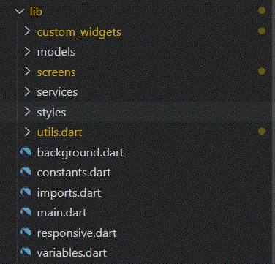

Figure 38. flutter project tree 1

* Custom widgets: this folder contains all reusable widgets.
* Models: this folder includes all our classes like courier, order, etc.. class.
* Screens: all screens of the application. And as shown in the next screenshot most of the screens have their own folder which contains two files, one for the UI and another for the logic.
* Services: this folder includes all external API calls.
* Utils: this is the helper folder. It contains all helper functions like date Time parsing.

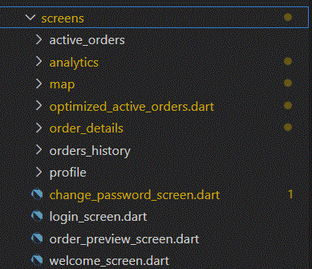

Figure 39. flutter project tree 2

After introducing the project structure used, let's dive into the implementation.

We have developed a user-friendly flutter application that facilitates the delivery process and makes it smoother. Our application provides some features that help couriers in their tasks like login, display assigned orders, order management, route optimization. So, let’s explore some of the important features.

1. Order State Management.

* Complete Order: Courier can mark order as completed after delivering it to the customer successfully and without any problems.
* Cancel Order: in case a problem happens and prevents the courier from delivering the order to the customer, the courier can mark the order as canceled and add a reason for cancellation.

1. Route Optimization

When a courier assigned some orders the application provide a powerful feature that reorder assigned orders and generate shortest path that visit each point once.

Advantages

* Reduce Delivery time.
* Reduce fuel consumption.
* Increase business profit.
* Enhance customer satisfaction.

## 5.2 Testing:

### 5.2.1 Application tests

#### 5.2.1.1 Login

|  |  |  |  |  |
| --- | --- | --- | --- | --- |
| Test scenario | prerequisites | steps | Expected output | status |
| Login with valid credentials | Courier must me registered | - Enter email.  - Enter Password | Redirect to assigned orders page | passed |
| Login with invalid credentials | - | - Enter Email.  - Enter Password | Display snackbar with error message | passed |

Login With invalid credentials Login with Valid Credentials

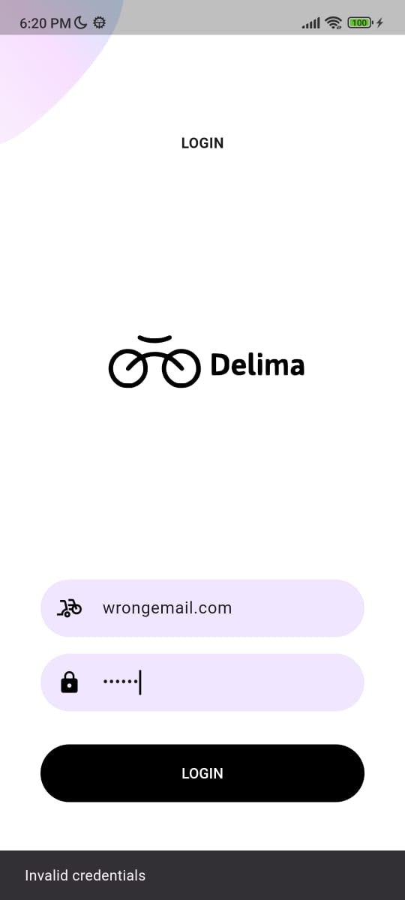 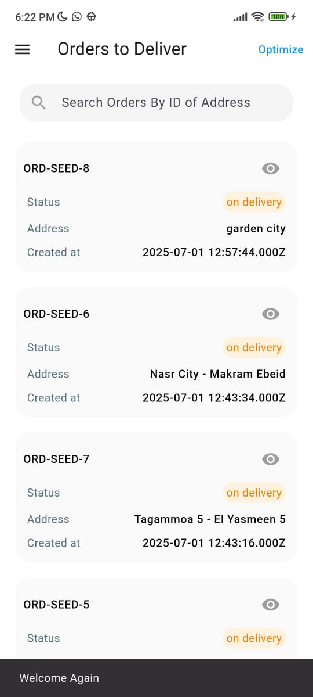

#### 5.2.1.2 order details

|  |  |  |  |  |
| --- | --- | --- | --- | --- |
| Test scenario | prerequisites | steps | Expected output | status |
| View order details | - logged in  - order assigned to the courier | - from assigned orders page tap on the order | Redirect to screen contains order details. | Passed |

View order details.



Figure 40. view order test

#### 5.2.1.3 Optimized Route

|  |  |  |  |  |
| --- | --- | --- | --- | --- |
| Test scenario | prerequisites | steps | Expected output | status |
| View optimized route for assigned orders and show orders after reordering | - orders are more than one order | - from the assigned orders page tap on “optimize” button.  - for displaying reordered orders tap on the order textButton. | Redirect to page contains map that display optimized route | passed |

View optimized route for assigned orders.

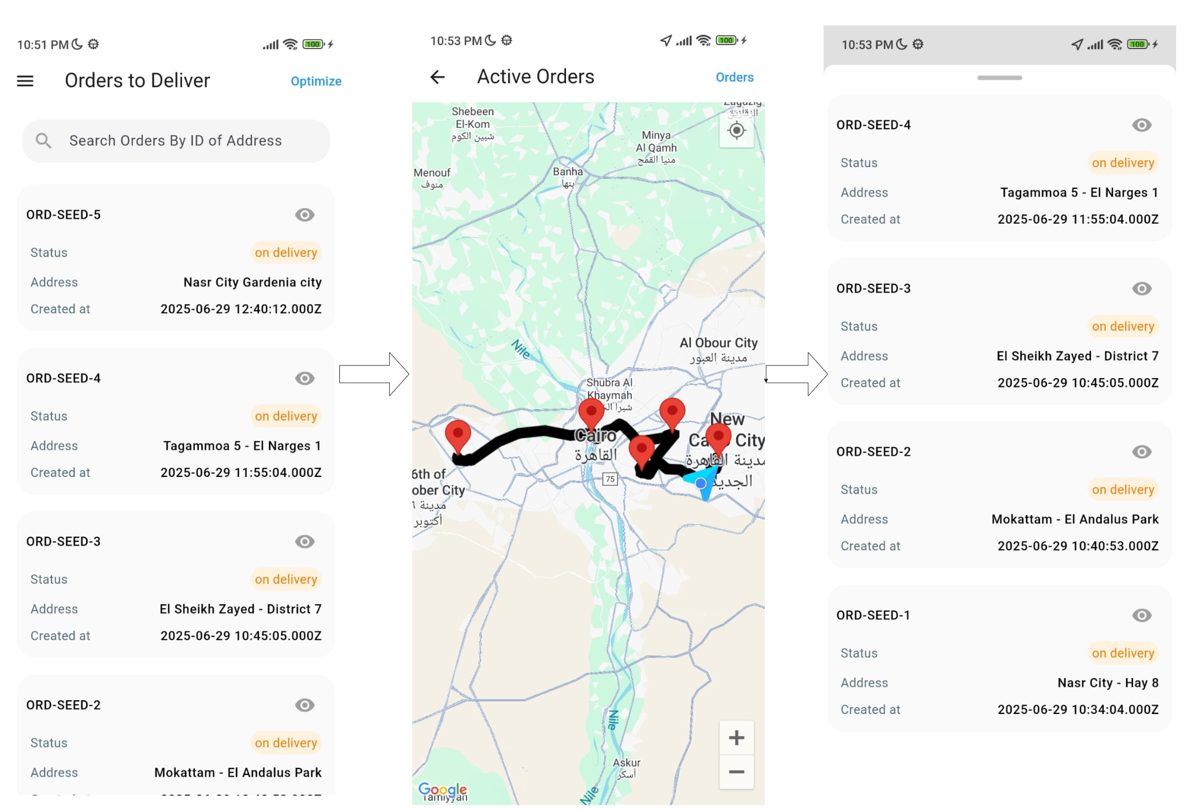

Figure 41. view optimized route test

# Chapter 6:Future work and Conclusion

## 6.1 Future work:

There is always room for enhancements in any developed system, especially when the project is built using modern technologies and addresses an expanding market need like last-mile delivery optimization.

One of the most critical aspects of preparing for production-grade usage is scaling the system effectively—not just vertically, but elastically and cost-efficiently.

A key direction for future deployment is migrating to Infrastructure as a Service (IaaS) using AWS-native architecture, with the following enhancements:

**1. Backend: Serverless-first Architecture**

* The backend will transition from a traditional monolithic web service to a serverless deployment using AWS Lambda and the Serverless Framework.
* Given that our API surface is relatively small, this transition is straightforward:
* All endpoints will be mapped to API Gateway routes.
* A single Lambda function can initially handle all routing logic, preserving our current RESTful design without introducing breaking changes.
* Over time, the architecture can evolve to use per-endpoint Lambdas, enabling fine-grained autoscaling and improved cold-start isolation.

**2. Frontend: S3 + CloudFront Deployment**

* The frontend will be deployed as a static site hosted on AWS S3, serving website builds directly from a secure, scalable bucket.
* A CloudFront CDN will be layered in front of the S3 bucket, enabling low-latency delivery, HTTPS support, caching, and edge optimization.

## 

## 6.2 Conclusion:

We presented an intelligent delivery management system designed to automate and optimize the last-mile delivery process for businesses. Our solution is capable of assigning orders efficiently, optimizing courier routes, and providing real-time tracking to enhance operational performance and customer satisfaction. We implemented the system using a modular architecture, with a React-based web dashboard, a Flutter mobile application, and a Node.js backend integrated with a PostgreSQL database to ensure smooth, scalable, and responsive performance across all components.

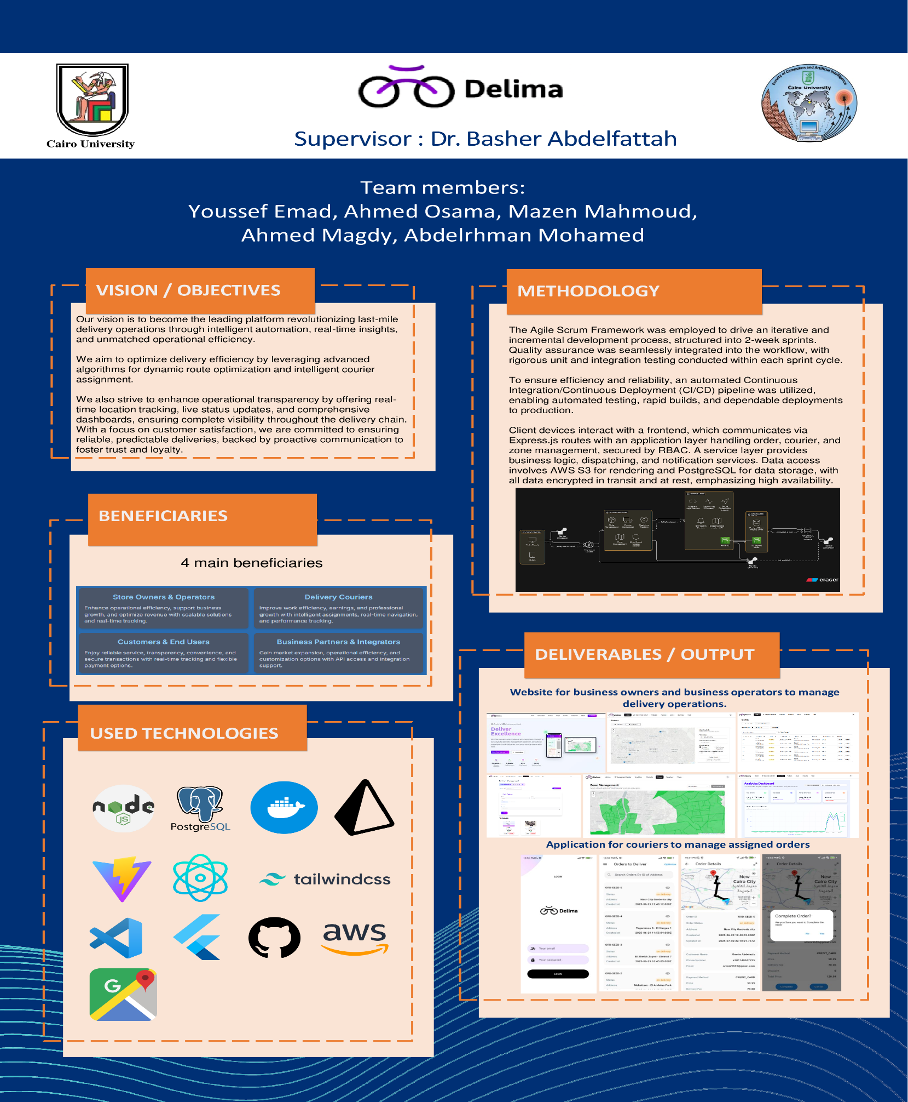

# References

[1] Research, S. (2024, December 17). Last mile delivery market size, Growth & statistics by 2033. Straits Research. <https://straitsresearch.com/report/last-mile-delivery-market>

[2] PricewaterhouseCoopers. (n.d.). Experience is everything: Here’s how to get it right. PwC. <https://www.pwc.com/us/en/services/consulting/library/consumer-intelligence-series/future-of-customer-experience.html#:~:text=Nearly%2080%25%20of%20American%20consumers,of%20a%20positive%20customer%20experience>.

[3] Komal Puri. (2024, June 13). Top last mile delivery statistics to consider. FarEye. <https://fareye.com/resources/blogs/last-mile-delivery-statistics>

[4] diggipacks.com. (2022, October 10). 5 last mile delivery challenges and how we can solve it?. Diggipacks l Unlimited Solutions. <https://diggipacks.com/en/last-mile-delivery-challenges/>

[5] Roboost. “How It Works?” Roboost. Accessed January 30, 2025. <https://roboost.ai/how-it-works>.

[6] “Circuit for Teams - Route Planning Software.” getcircuit. Accessed January 30, 2025. <https://getcircuit.com/teams>.

[7] “Features.” OptimoRoute, July 19, 2022. <https://optimoroute.com/features/>.

[8] Bosta. (n.d.). Shipping & Delivery Services in Egypt. Bosta. Accessed January 30, 2025. https://bosta.co

[9] Talabat. (n.d.). Vendor Registration – Partner With Talabat. Accessed January 30, 2025. <https://www.talabat.com/uae/vendor-registration>

[10] Elmenus. (n.d.). Partner With Elmenus. Accessed January 30, 2025. <https://partner.elmenus.com>

[11] Noon. (n.d.). Sell on Noon – Seller Portal. Accessed January 30, 2025. <https://sell.noon.com>